

Laboratory Record
CSE3015 AWS Cloud Practitioner

A14+D11+D12, BL2026270100433,
Fall Semester :2026-2027

Group No. 10

Programme Outcomes (POs):
- Engineering knowledge: Apply the knowledge of mathematics, science, engineering fundamentals, and an engineering specialization to the solution of complex engineering problems.
- Problem analysis: Identify, formulate, review research literature, and analyze complex engineering problems reaching substantiated conclusions using first principles of mathematics, natural sciences, and engineering sciences.
- Design/development of solutions: Design solutions for complex engineering problems and design system components or processes that meet the specified needs with appropriate consideration for public health and safety, and cultural, societal, and environmental considerations.
- Conduct investigations of complex problems: Use research-based knowledge and research methods including design of experiments, analysis and interpretation of data, and synthesis of information to provide valid conclusions.
- Modern tool usage: Create, select, and apply appropriate techniques, resources, and modern engineering and IT tools including prediction and modeling to complex engineering activities with an understanding of the limitations.
- The engineer and society: Apply reasoning informed by contextual knowledge to assess societal, health, safety, legal, and cultural issues and the consequent responsibilities relevant to professional engineering practice.
- Environment and sustainability: Understand the impact of professional engineering solutions in societal and environmental contexts, and demonstrate the knowledge of, and need for, sustainable development.
- Ethics: Apply ethical principles and commit to professional ethics and responsibilities and norms of the engineering practice.
- Individual and teamwork: Function effectively as an individual, and as a member or leader in diverse teams and in multidisciplinary settings.
- Communication: Communicate effectively on complex engineering activities with the engineering community and society at large, including comprehending and writing effective reports and design documentation, making effective presentations, and giving and receiving clear instructions.
- Project management and finance: Demonstrate knowledge and understanding of engineering and management principles and apply these to one's own work, as a member and leader in a team, to manage projects in multidisciplinary environments.
- Life-long learning: Recognize the need for, and have the preparation and ability to engage in independent and life-long learning in the broadest context of technological change.

Exp. No. | Date | Name of the Experiment | Page Number
1 | 06-09-2026 | Procedure to Create an AWS Account and Working with Amazon S3
2 | 06-09-2026 | Create a Lambda Function and Configure Event Triggers
3 | 06-09-2026 | Identity and Access Management (IAM) in AWS
4 | 06-09-2026 | Launching EC2 Instances Using PuTTY
5 | 06-09-2026 | Hands-on Session on Elastic Beanstalk

INDEX

Exp No: 1 | Procedure to Create an AWS Account and Working with  Amazon S3
06-09-2026

Aim:
- To create an Amazon Web Services (AWS) account and explore the AWS Management Console.
- To create an S3 bucket, enable versioning, configure encryption, set a bucket policy, and perform file upload and download operations.

Objectives:
- To understand the process of creating and setting up an AWS account.
- To explore and navigate the AWS Management Console.
- To create and configure an Amazon S3 bucket with versioning and encryption.
- To apply bucket policies and perform object upload/download operations.
- To understand public access settings and their security implications.

Tools Used:
- Amazon Web Services (AWS) — aws.amazon.com
- Web Browser (Chrome / Firefox)
- AWS Management Console
- Amazon S3 (Simple Storage Service)

Theory:
Amazon Web Services (AWS) is a comprehensive cloud computing platform provided by Amazon. It offers a wide range of cloud services including computing power, storage, databases, networking, machine learning, and more. AWS allows individuals and organizations to access scalable infrastructure on a pay-as-you-go basis without upfront investment in physical hardware.

Amazon S3 (Simple Storage Service) is an object storage service offering industry-leading scalability, data availability, security, and performance. S3 allows users to store and retrieve any amount of data at any time. Data is stored as objects within buckets. Each object consists of a file and optionally any metadata describing that file.

Key S3 Concepts:
- Bucket: A container for storing objects (files). Bucket names must be globally unique.
- Object: A file stored in a bucket along with its metadata.
- Versioning: Enables keeping multiple versions of an object in the same bucket.
- Encryption (SSE): Server-Side Encryption protects data at rest using AWS-managed or KMS keys.
- Bucket Policy: A JSON-based access control policy that defines who can access your bucket.
- Regions: AWS data centers are distributed globally. Selecting a nearby region reduces latency.

Procedure:
Part A: Creating an AWS Account

Step 1: Visit AWS Official Website
- Go to: https://aws.amazon.com
- Click on "Create an AWS Account" (top-right corner).

Step 2: Enter Email & Set Root User Details
- Email address: Use a valid email (e.g., Gmail).
- Password: Create a strong password.
- AWS Account name: Enter your name or organization name.
- Click Continue.

Step 3: Choose Account Type
- Choose Personal (for students/individual use) or Professional (for company/organizational use).
- Enter full name, address, and mobile number.

Step 4: Payment Information
- Enter a credit/debit card (Visa/MasterCard/UPI-enabled cards work).
- ₹2 is deducted temporarily for card verification (refunded later).
- Click Verify and Add.

Step 5: Identity Verification
- Select SMS or voice call for phone verification.
- Enter the OTP (One Time Password) sent to your mobile.
- Once verified, click Continue.

Step 6: Select a Support Plan
- Choose Basic Support Plan (Free) — includes 12-month Free Tier (e.g., EC2, S3, Lambda, RDS have free usage limits).
- Click Complete Sign-Up.

Step 7: Sign In to AWS Console
- Go to https://console.aws.amazon.com
- Login using your email (root user) and password.
- You now have access to the AWS Management Console.

Note: Set up billing alerts to avoid unexpected charges.

Part B: Working with Amazon S3
Step 1: Create an S3 Bucket
- Sign in to AWS Console and go to S3 from the Services menu.
- Click Create bucket.
- Fill in:
    - Bucket name: Must be globally unique (e.g., my_s3bucket2025).
    - Region: Choose your preferred region (e.g., Asia Pacific (Mumbai)).
- Uncheck "Block all public access" only if you need public access (not recommended for sensitive data).
- Leave other settings default.
- Click Create bucket.

Issue 1: Region must be selected from the top bar of the console.
Issue 2: If "Block all public access" is unchecked, the bucket policy editor becomes accessible. Both approaches should be tried and documented with screenshots to understand the difference.

Step 2: Enable Bucket Versioning
- Go to your bucket → click the Properties tab.
- Scroll to Bucket Versioning → click Edit → Enable → Save changes.
- Versioning keeps multiple versions of an object (useful in case of accidental deletes or overwrites).

Step 3: Enable Server-Side Encryption
- In the Properties tab, scroll to Default encryption.
- Click Edit → Choose:
  - AWS Key (SSE-S3) — simple and free.
  - Or KMS (SSE-KMS) — more secure, supports audit logs.
- Click Save changes.

Step 4: Add a Bucket Policy (Optional: Allow Read Access)
- Go to Permissions tab → Bucket Policy → Edit.
- Paste the following example policy to make objects publicly readable:
{
"Version": "2012-10-17",
"Statement": [
{
"Sid": "PublicReadGetObject",
"Effect": "Allow",
"Principal": "*",
"Action": "s3:GetObject",
"Resource": "arn:aws:s3:::my_s3bucket2025/*"
}
]
}

Step 5: Upload an Object
- Open your bucket.
- Click Upload → Add Files (e.g., a PDF, image, or .txt file).
- Click Upload.

Issue: You can create a simple text file on your system and upload it if you do not have another file handy.

Step 6: Download an Object
- Go to your bucket → Click on the object.
- Click Download.

Output:
- Screenshot 1: AWS Account Creation — Sign-in page

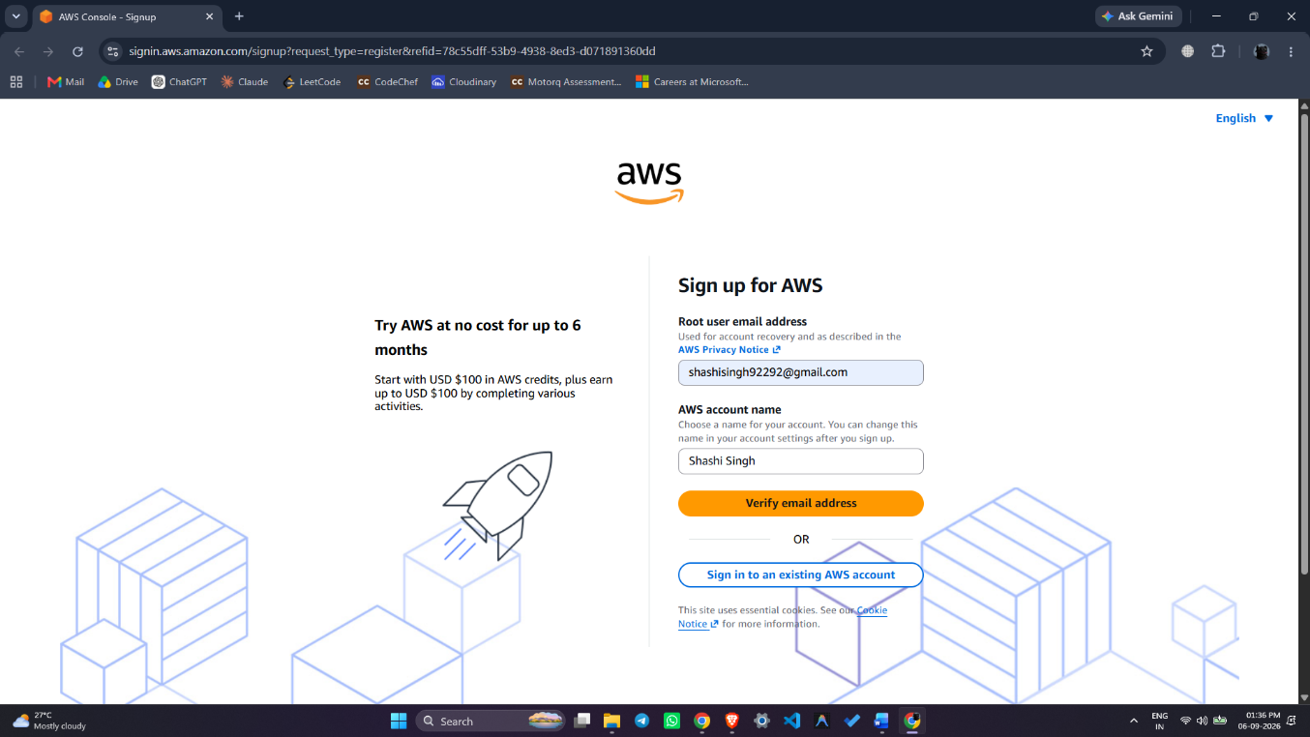

- Screenshot 2: AWS Management Console Dashboard

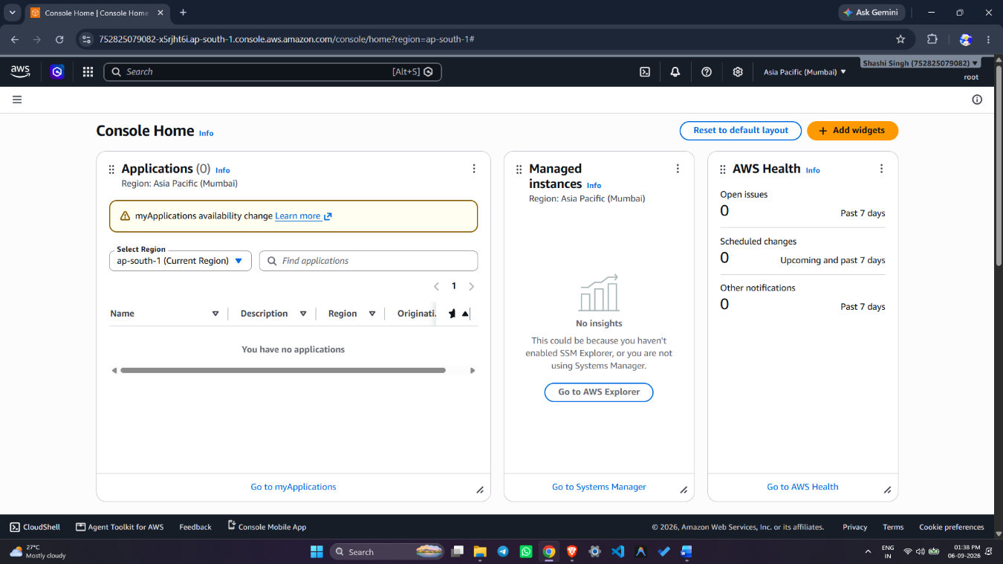

- Screenshot 3: S3 Bucket Created (name, region visible)

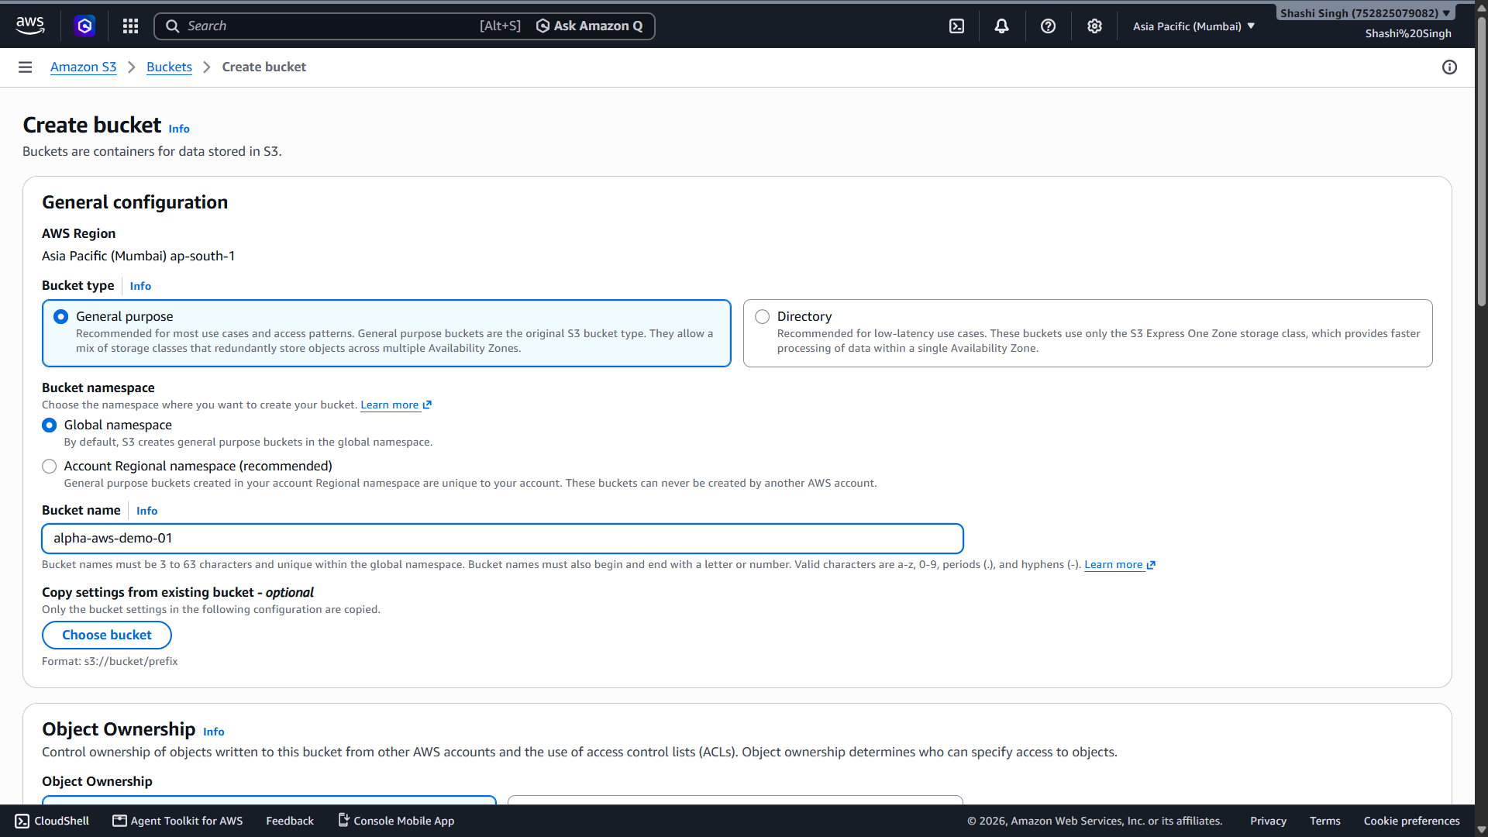

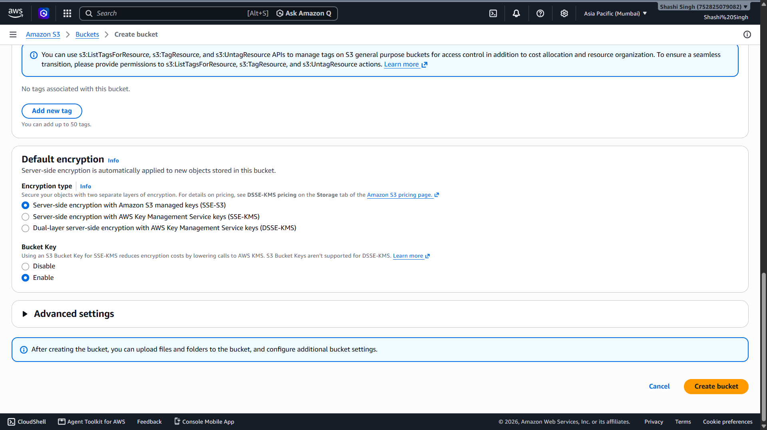

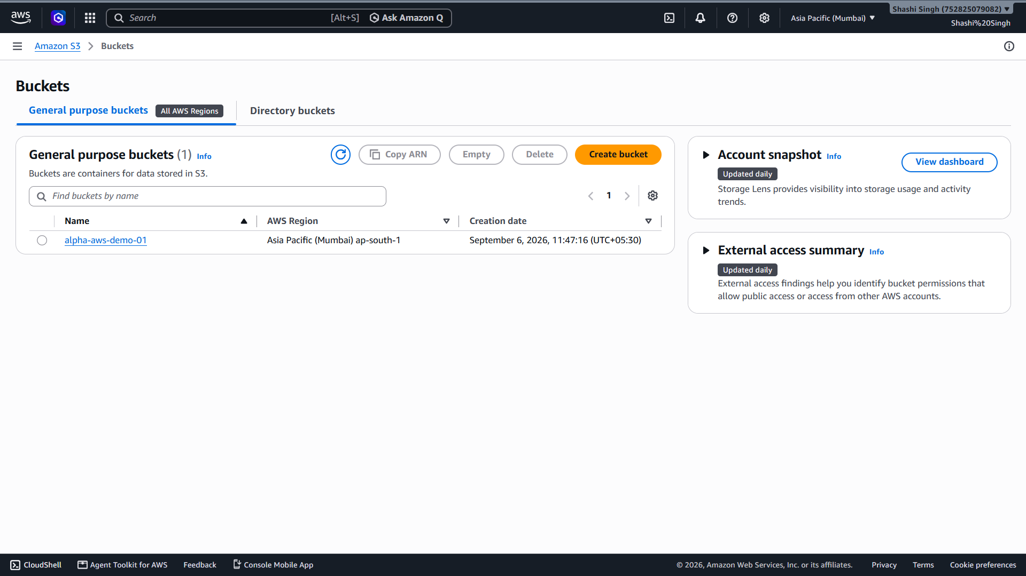

Result:
Successfully created an AWS account and logged into the AWS Management Console. An Amazon S3 bucket was created with a globally unique name in the Asia Pacific (Mumbai) region. Bucket versioning and server-side encryption (SSE-S3) were enabled. A bucket policy was applied for public read access, and a file was successfully uploaded to and downloaded from the S3 bucket.

References:
- https://aws.amazon.com/getting-started/
- https://docs.aws.amazon.com/AmazonS3/latest/userguide/creating-bucket.html
- https://docs.aws.amazon.com/AmazonS3/latest/userguide/Versioning.html
- https://docs.aws.amazon.com/AmazonS3/latest/userguide/serv-side-encryption.html

Exp No: 2 | Create a Lambda Function and Configure Event Triggers
06-09-2026 | Create a Lambda Function and Configure Event Triggers

Aim:
- To create an AWS Lambda function using Python and configure an S3 event trigger.
- To test the Lambda function and verify its output using Amazon CloudWatch Logs.

Objectives:
- To understand the concept of serverless computing using AWS Lambda.
- To create an S3 bucket and use it as an event source for a Lambda function.
- To write and deploy Python code in AWS Lambda.
- To configure S3 event triggers to invoke the Lambda function automatically.
- To attach appropriate IAM permissions to the Lambda execution role.
- To verify Lambda execution through CloudWatch Logs.

Tools Used:
- Amazon Web Services (AWS) Management Console
- AWS Lambda
- Amazon S3
- Amazon CloudWatch
- AWS IAM (Identity and Access Management)
- Python 3.9 (Runtime Environment)

Theory:
AWS Lambda is a serverless computing service that lets you run code without provisioning or managing servers. Lambda automatically scales your application by running code in response to each trigger. You pay only for the compute time consumed — there is no charge when your code is not running.

An event trigger is a mechanism that automatically invokes a Lambda function in response to an event, such as a file being uploaded to an S3 bucket, a change in a DynamoDB table, or an HTTP request via API Gateway.

Key Concepts:
- Lambda Function: A piece of code that runs in response to events.
- Handler: The entry point of a Lambda function (e.g., lambda_handler in Python).
- Execution Role: An IAM role that grants the Lambda function permission to access AWS services.
- Event Source / Trigger: A service that invokes Lambda (here, Amazon S3).
- CloudWatch Logs: Used to monitor and debug Lambda function executions.
- S3 Event Notification: Automatically sends a message to Lambda when objects are created/deleted in S3.

Procedure:
Step 1: Create an S3 Bucket (if not already created)
- Go to the AWS Management Console → Open Amazon S3.
- Click Create bucket.
- Give a unique name (e.g., my-demo-upload-bucket).
- Choose a region (e.g., Asia Pacific (Mumbai)).
- Leave defaults and click Create bucket.

Step 2: Create a Lambda Function
- Open the AWS Lambda Console: https://console.aws.amazon.com/lambda
- Click Create function → Choose Author from scratch.
- Fill in:
  - Function name: logUploadedFile
  - Runtime: Python 3.9 (or latest available version)
  - Execution role: Create a new role with basic Lambda permissions
- Click Create function.

Step 3: Add Python Code to Lambda
- Scroll to the Code source section.
- Replace the default code with the following:

import json

def lambda_handler(event, context):
# Extract bucket name and file name from the event
bucket = event['Records'][0]['s3']['bucket']['name']
key = event['Records'][0]['s3']['object']['key']
print(f"File uploaded: {key} in bucket: {bucket}")
return {
'statusCode': 200,
'body': json.dumps(f"File {key} uploaded to {bucket}")
}

- Click Deploy.

Step 4: Add S3 Trigger to the Lambda Function
- In the Function overview, click + Add trigger.
- Choose S3.
- Set:
  - Bucket: Choose the bucket created earlier (my-demo-upload-bucket)
  - Event type: All object create events
- Click the acknowledgment checkbox → Click Add.

Note: This grants S3 permission to invoke your Lambda function whenever a file is uploaded.
Step 5: Update Lambda Execution Role to Allow S3 Read Access
- Go to the Configuration tab → Permissions.
- Click on the Role name → This opens the IAM console.
- Click Add permissions → Attach policies.
- Search for and select: AmazonS3ReadOnlyAccess.
- Click Next → Add permissions.

Step 6: Test the Lambda Function
- Open the Amazon S3 Console.
- Go to your bucket (my-demo-upload-bucket).
- Click Upload → Add any small file (e.g., sample.txt) → Click Upload.

Step 7: View the Output in CloudWatch Logs
- Go back to the Lambda function.
- Click Monitor tab → View logs in CloudWatch.
- Click the latest log stream.
- We see logs similar to:

START RequestId: xxx
File uploaded: sample.txt in bucket: my-demo-upload-bucket
END RequestId: xxx

This confirms that the Lambda function was successfully triggered and executed.

Output:

- Screenshot 1: S3 Bucket created (alpha-aws-demo-01)

- Screenshot 2: Lambda function created (logUploadedFile) with Python 3.9 runtime

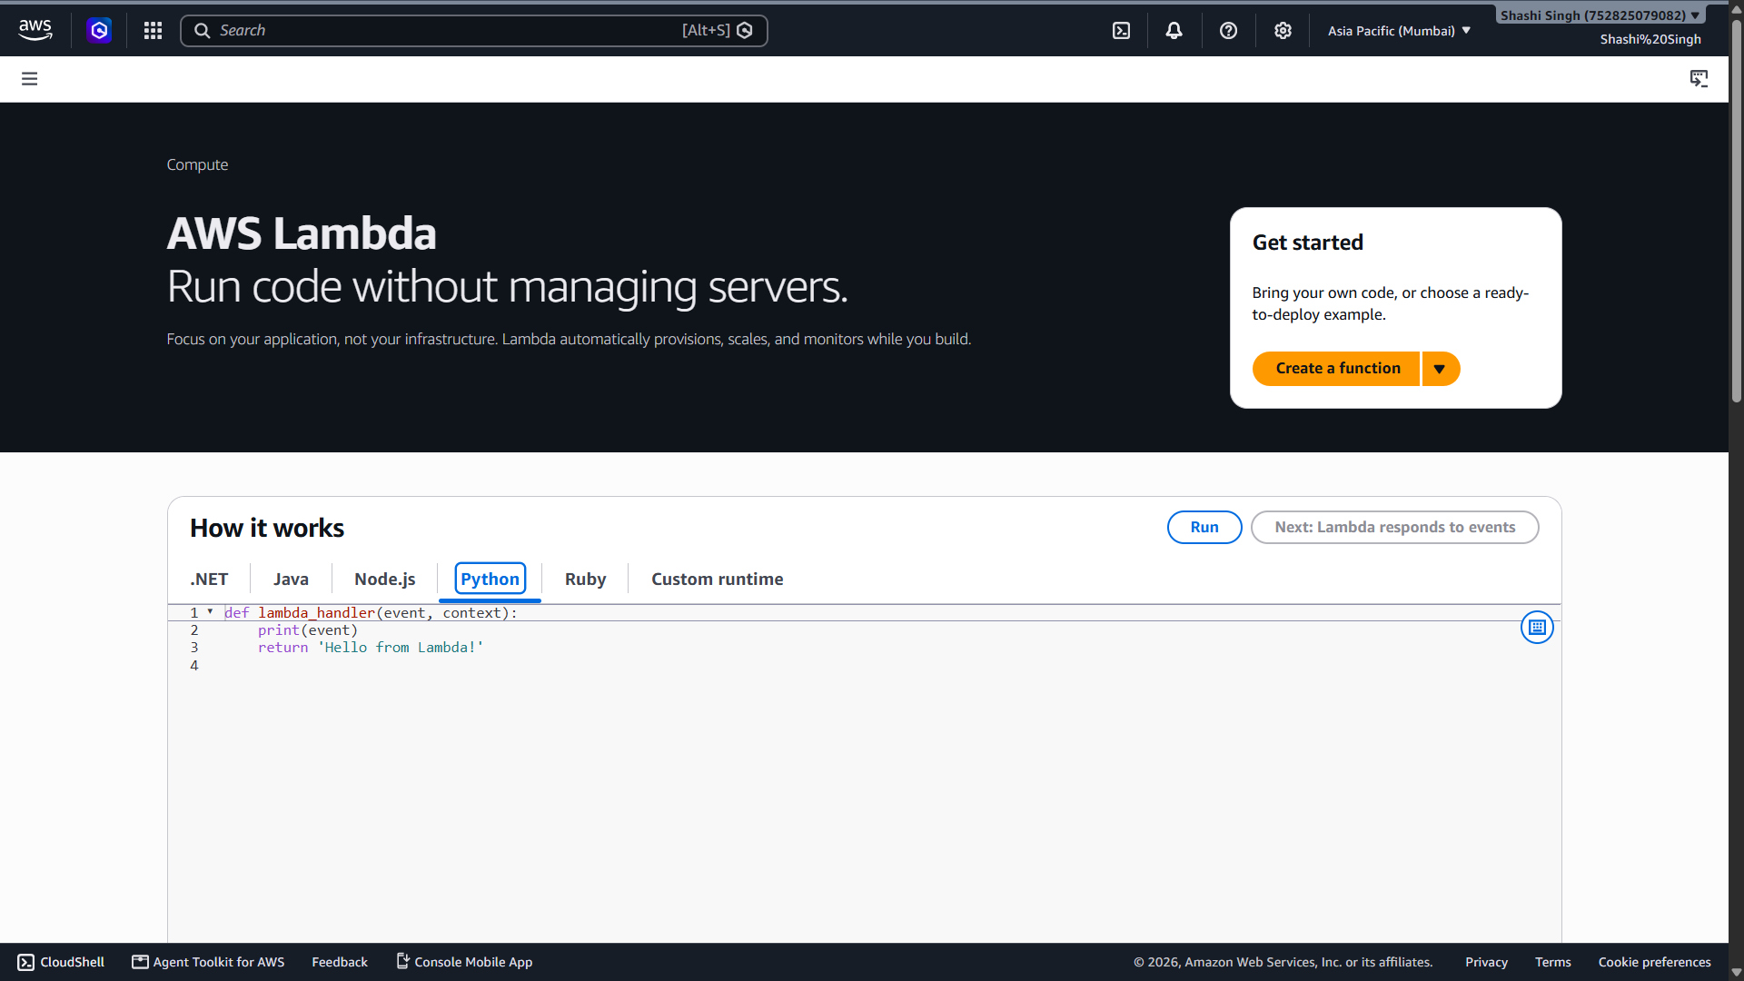

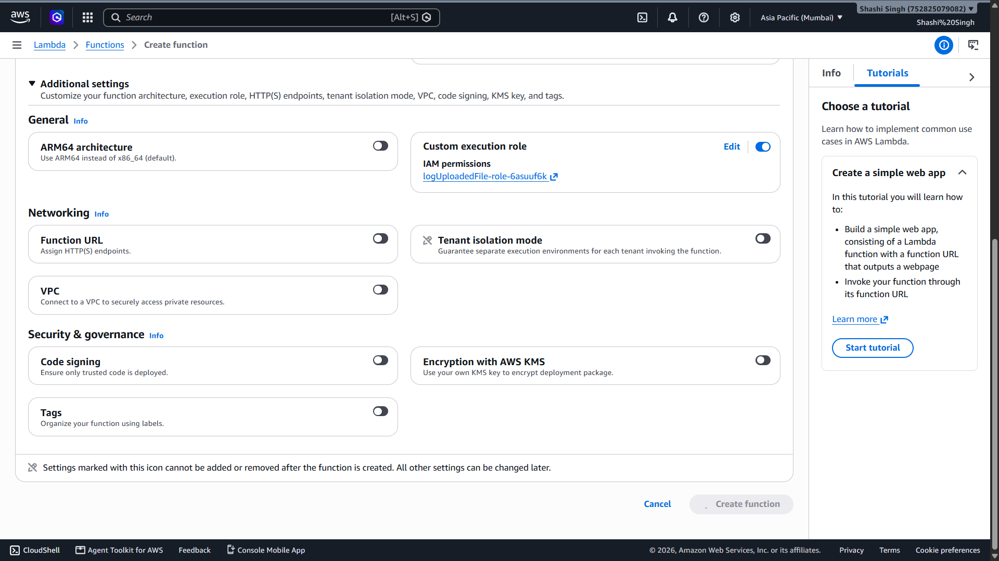

- Screenshot 3: Python code deployed in Lambda Code source editor

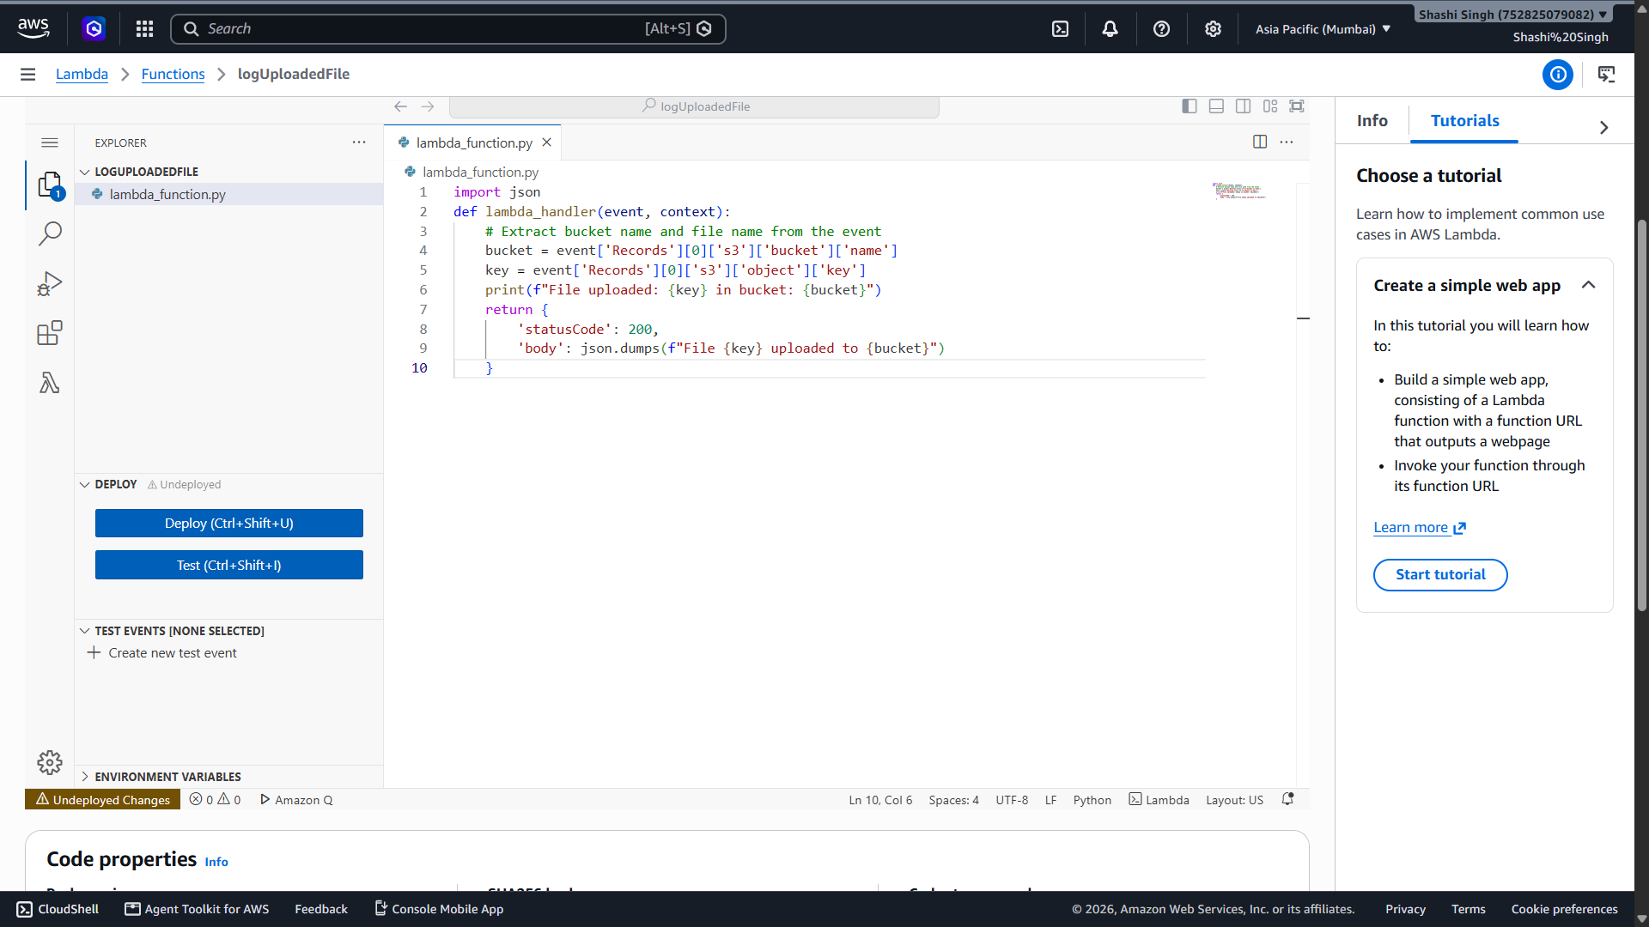

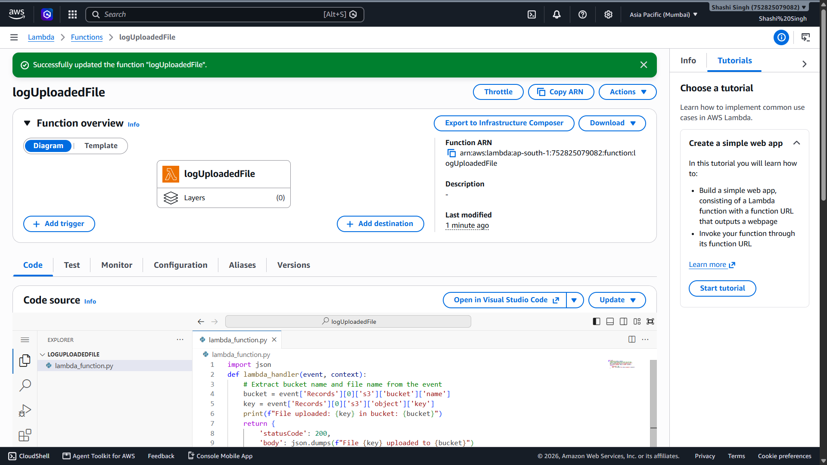

- Screenshot 4: S3 trigger added in Function overview

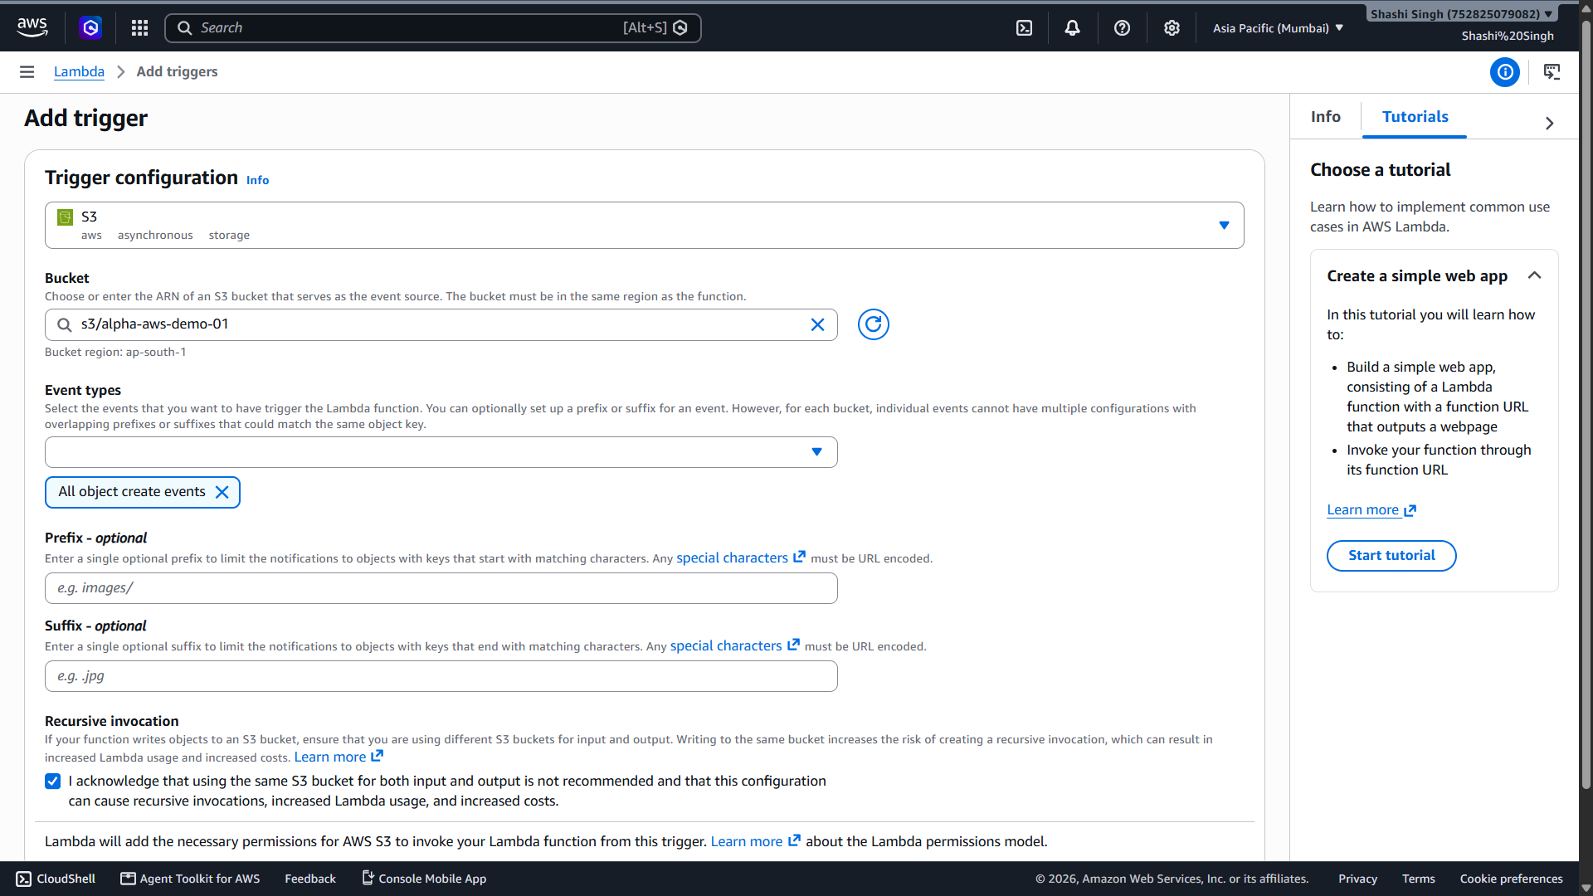

- Screenshot 5: AmazonS3ReadOnlyAccess policy attached to execution role (IAM)

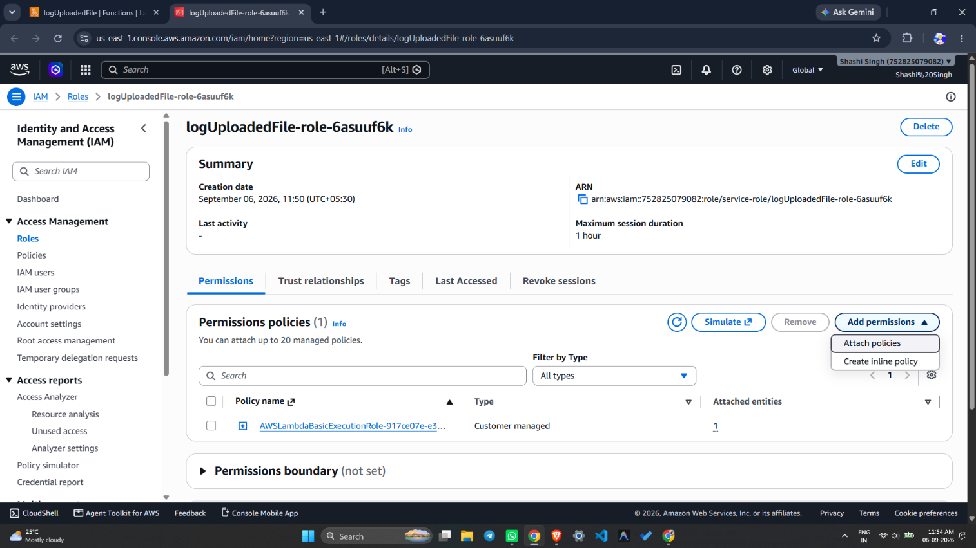

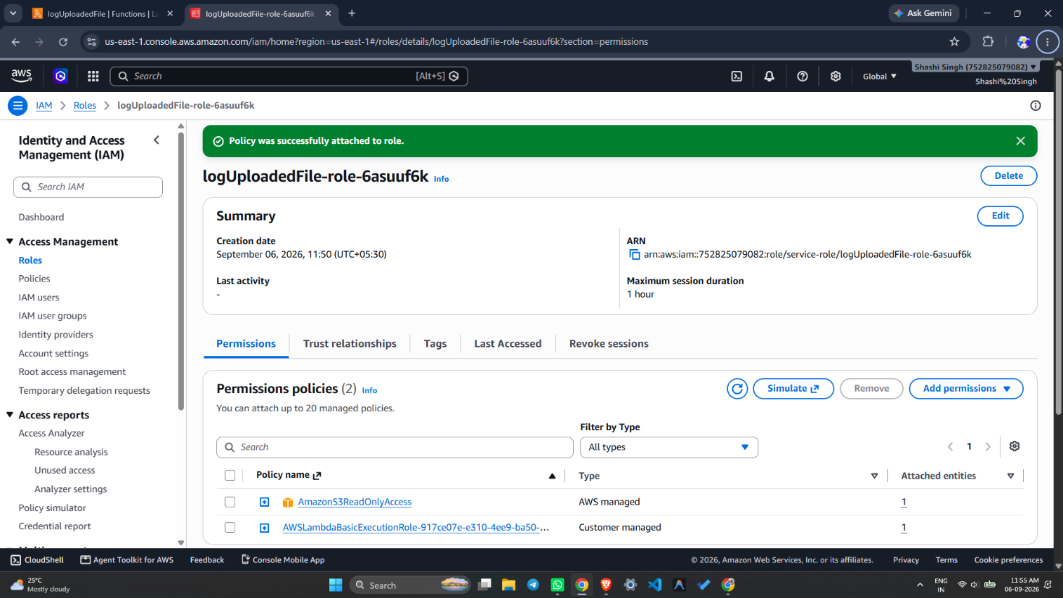

- Screenshot 6: File (sample.txt) uploaded to S3 bucket

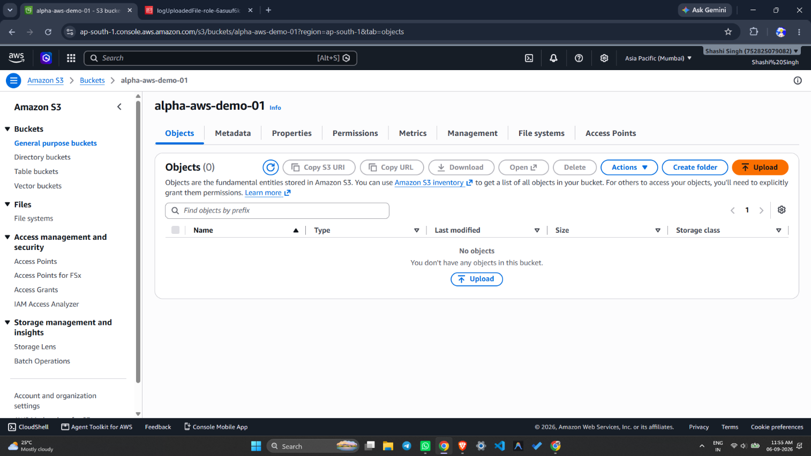

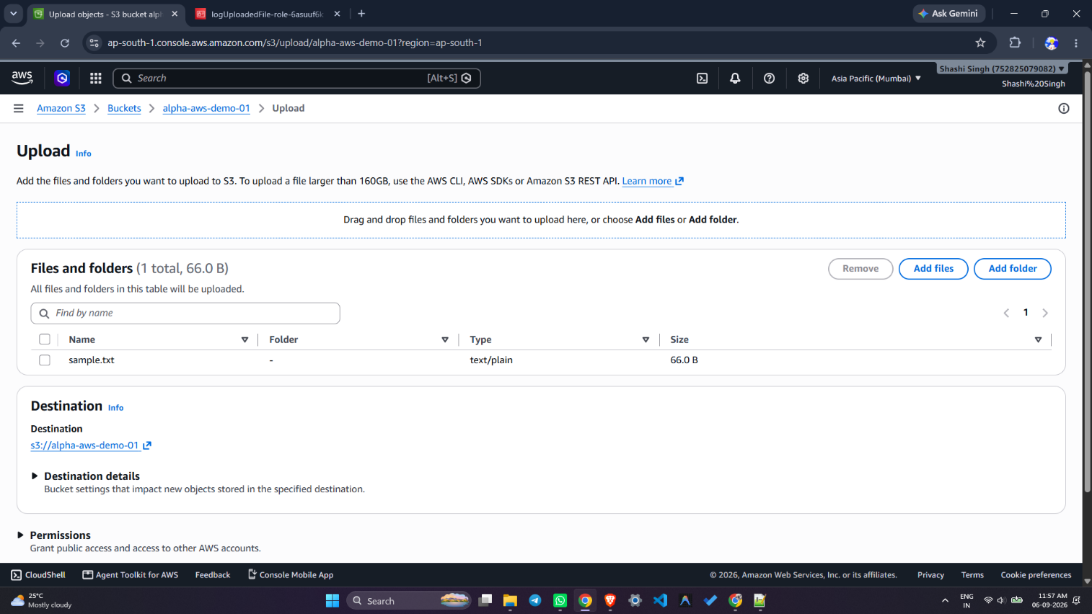
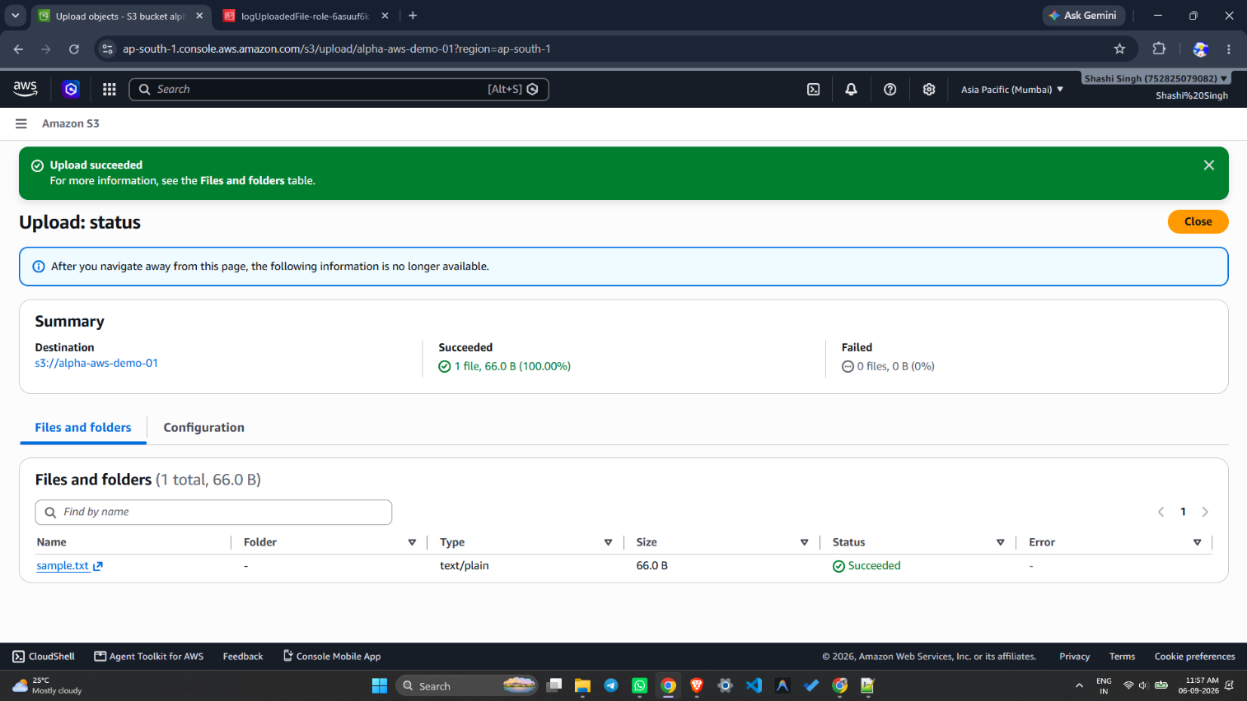

- Screenshot 7: CloudWatch Logs showing "File uploaded: sample.txt in bucket: my-demo-upload-bucket"

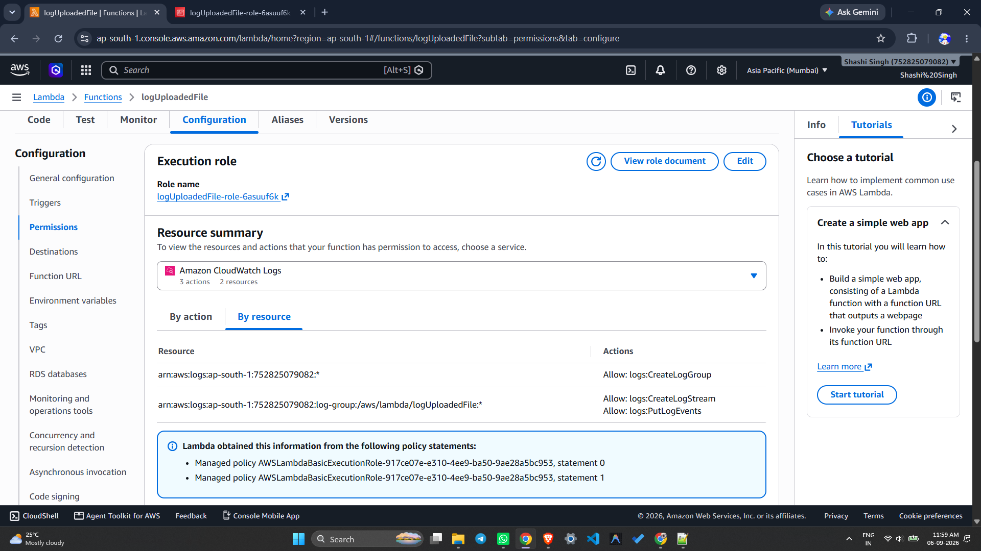

Result:
Successfully created an AWS Lambda function using Python 3.9 with the name logUploadedFile. An S3 event trigger was configured to automatically invoke the Lambda function upon file upload. The Lambda execution role was updated with AmazonS3ReadOnlyAccess permissions. Upon uploading a file (sample.txt) to the S3 bucket, the Lambda function was triggered automatically, and the output was verified in Amazon CloudWatch Logs.

References:
- https://docs.aws.amazon.com/lambda/latest/dg/getting-started.html
- https://docs.aws.amazon.com/lambda/latest/dg/with-s3.html
- https://docs.aws.amazon.com/AmazonCloudWatch/latest/logs/Working-with-log-groups-and-streams.html
- https://aws.amazon.com/lambda/

Exp No: 3 | Identity and Access Management (IAM) in AWS
06-09-2026 | Identity and Access Management (IAM) in AWS

Aim:
- To create and manage AWS Identity and Access Management (IAM) users, groups, roles, and policies.
- To manage access permissions to AWS resources and verify them using the IAM Policy Simulator.

Objectives:
- To understand the concept of IAM and its components (users, groups, roles, policies).
- To create an IAM user and configure console access.
- To create an IAM group and attach policies to it.
- To add users to groups and verify inherited permissions.
- To create a custom IAM policy using JSON.
- To create an IAM role for AWS services.
- To test and verify permissions using the IAM Policy Simulator.

Tools Used:
- Amazon Web Services (AWS) Management Console
- AWS IAM (Identity and Access Management)
- Amazon S3 (for testing permissions)
- IAM Policy Simulator — https://policysim.aws.amazon.com
- Web Browser (Chrome / Firefox)

Theory:
AWS Identity and Access Management (IAM) is a web service that helps you securely control access to AWS resources. IAM allows you to manage who is authenticated (signed in) and authorized (has permissions) to use AWS resources.

Key IAM Components:
- User: An entity that represents a person or application that can interact with AWS. Each user has unique credentials.
- Group: A collection of IAM users. Permissions assigned to a group are inherited by all users in it.
- Role: An IAM identity with specific permissions that can be assumed by AWS services or users. Roles are not associated with a specific person.
- Policy: A JSON document that defines what actions are allowed or denied on which resources. Policies are attached to users, groups, or roles.

Types of Policies:
- AWS Managed Policies: Pre-built by AWS (e.g., AmazonS3ReadOnlyAccess).
- Customer Managed Policies: Custom policies created by the user.
- Inline Policies: Policies embedded directly into a user, group, or role.

Procedure:
Step 1: Log in to AWS Console
- Go to AWS Management Console and sign in using the root account.
- The root account has full IAM access by default.

Step 2: Create an IAM User
- Go to Services → IAM → Users → Add users.
- Enter User name: e.g., Alice.
- Select Access type:
  - Programmatic access — for AWS CLI or SDK.
  - AWS Management Console access — allows browser login (select this for testing).
- Set a Console password (Autogenerated or Custom).
- Enable Require password reset if needed.
- Click Next: Permissions → choose Attach existing policies directly.
- Select AmazonS3ReadOnlyAccess (limited access — user can only read S3).
- Click Next: Tags (optional) → Next: Review → Create user.
- Download the .csv file with login credentials if needed.

Step 3: Create an IAM Group
- Go to IAM → Groups → Create group.
- Enter Group name: e.g., Developers.
- Attach policy: AmazonS3ReadOnlyAccess.
- Click Create group.

Step 4: Add Users to the Group
- Go to Users → Alice → Add to Group.
- Select Developers group → click Add.
- Alice now inherits all permissions from the Developers group.

Step 5: Create IAM Policy (Optional)
- Go to IAM → Policies → Create policy.
- Select the JSON tab and enter the following:

{
"Version": "2012-10-17",
"Statement": [
{
"Effect": "Allow",
"Action": ["s3:GetObject", "s3:ListBucket"],
"Resource": [
"arn:aws:s3:::my-bucket",
"arn:aws:s3:::my-bucket/*"
]
}
]
}

- Click Review policy → Name it S3ReadOnlyPolicy → Create policy.
- Attach it to the desired User or Group.

Step 6: Create IAM Role (Optional for Services)
- Go to IAM → Roles → Create role.
- Select AWS service → e.g., EC2.
- Attach policy → e.g., AmazonS3FullAccess.
- Name the role → e.g., EC2S3AccessRole.
- Click Create role.

Step 7: Test IAM User Access & Use IAM Policy Simulator

Step A: Prepare test environment (as Root User)
- Log in as Root User.
- Go to S3 → Create an S3 bucket and upload a sample file (test.txt).
- Log out from Root User.

Step B: Login as IAM User (Alice)
- Go to AWS Management Console → IAM user sign-in.
- Enter Account ID / alias (from root account → IAM dashboard).
- IAM user name: Alice | Password: (set during creation).
- Click Sign in.
- Verify that Alice can list/read S3 but cannot write or delete.

Step C: Use IAM Policy Simulator
- Log in as Root User.
- Go to Services → IAM → Policy Simulator (left side menu).
- Direct link: https://policysim.aws.amazon.com
- Select the IAM Identity to test (User: Alice, Group: Developers, or Role: EC2S3AccessRole).
- This loads all attached policies for that identity.

Choose a Service and Action:
- Select AWS service: Amazon S3.
- Select Actions: ListBucket, GetObject, PutObject.

Run the Simulation:
- Click Run Simulation.
- Results will show whether each action is Allowed ✅ or Denied ❌.

Interpret Results:
- If Allowed → The policy grants that permission.
- If Denied → The policy restricts it, or an explicit deny exists.

Output:
- Screenshot 1: IAM Dashboard overview

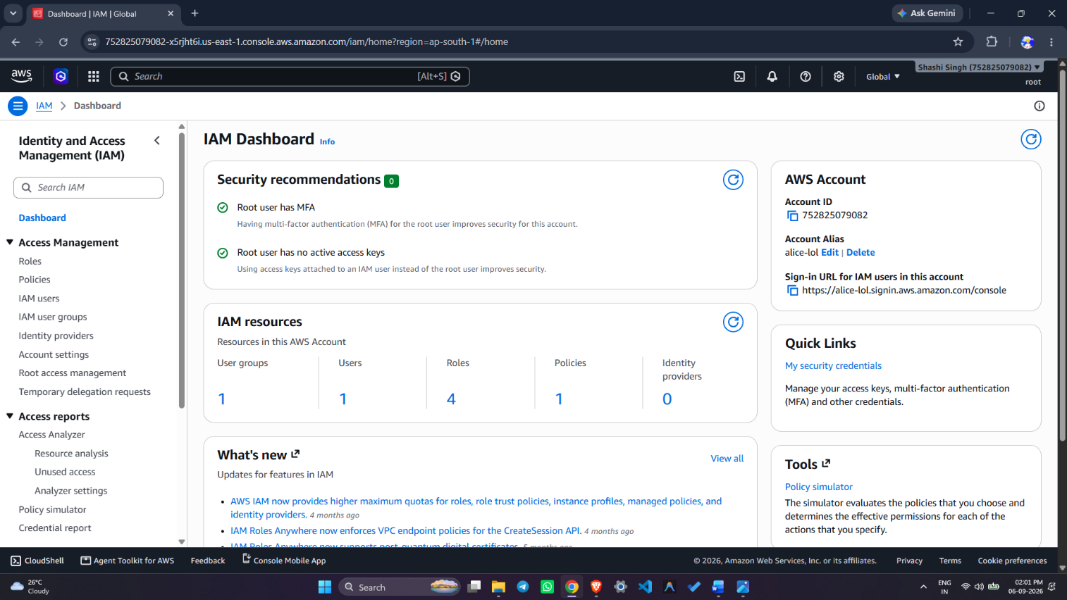

- Screenshot 2: IAM User "Alice" created with AmazonS3ReadOnlyAccess policy

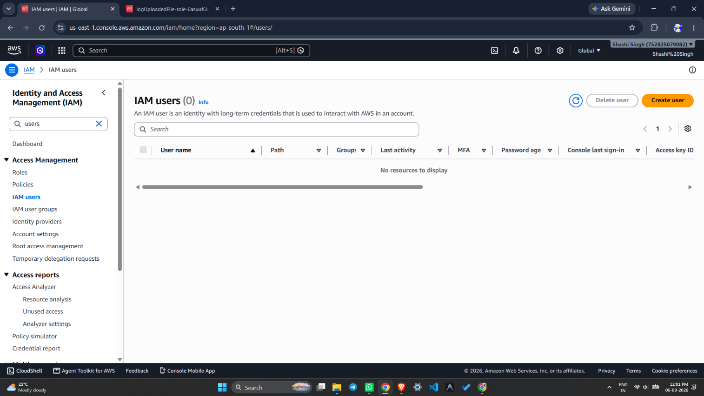

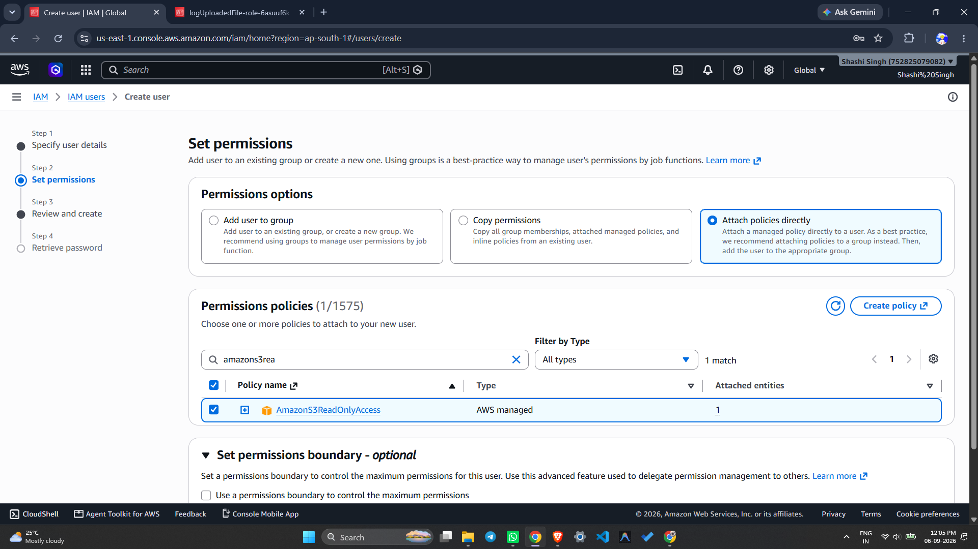
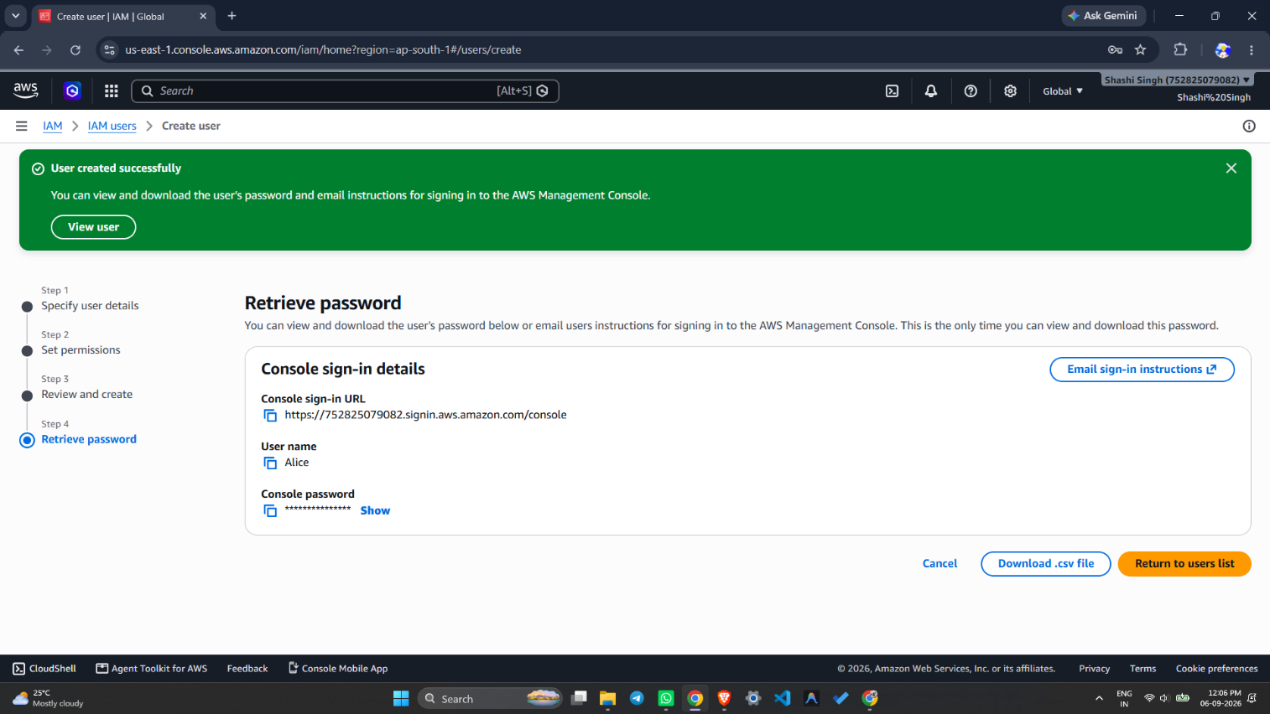

- Screenshot 3: IAM Group "Developers" created with policy attached

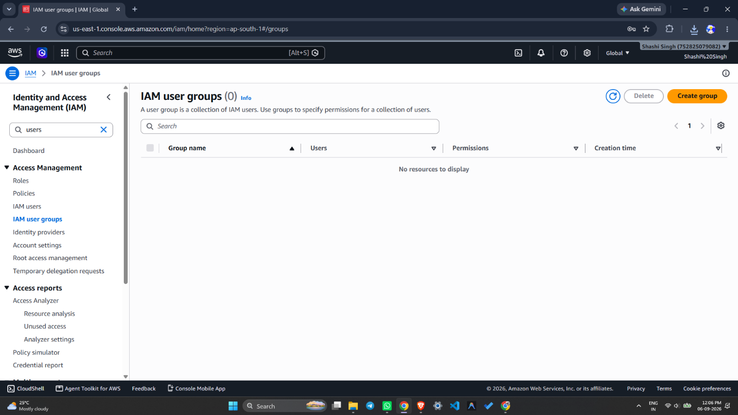
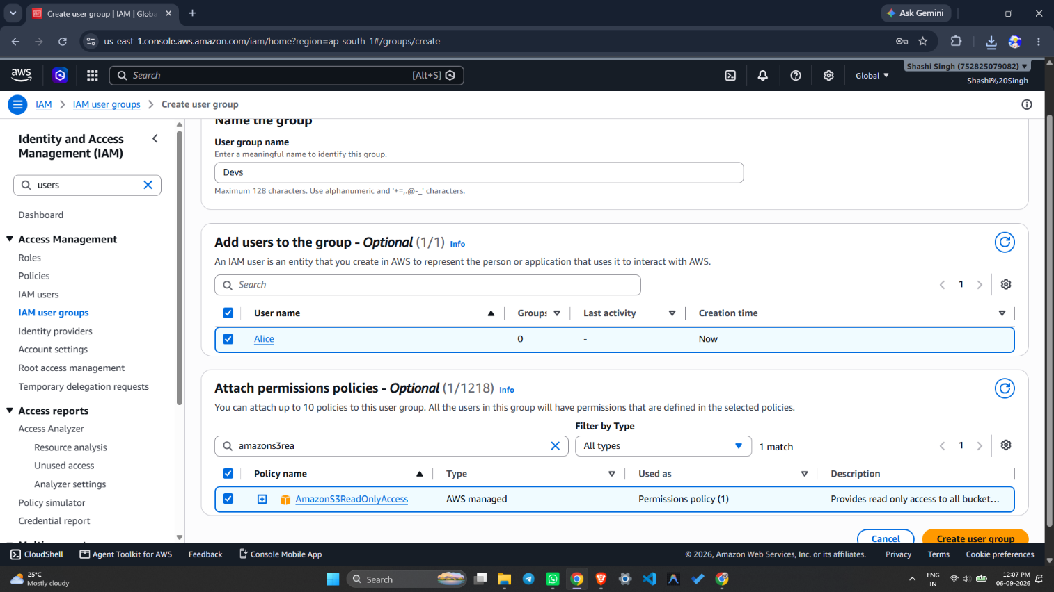

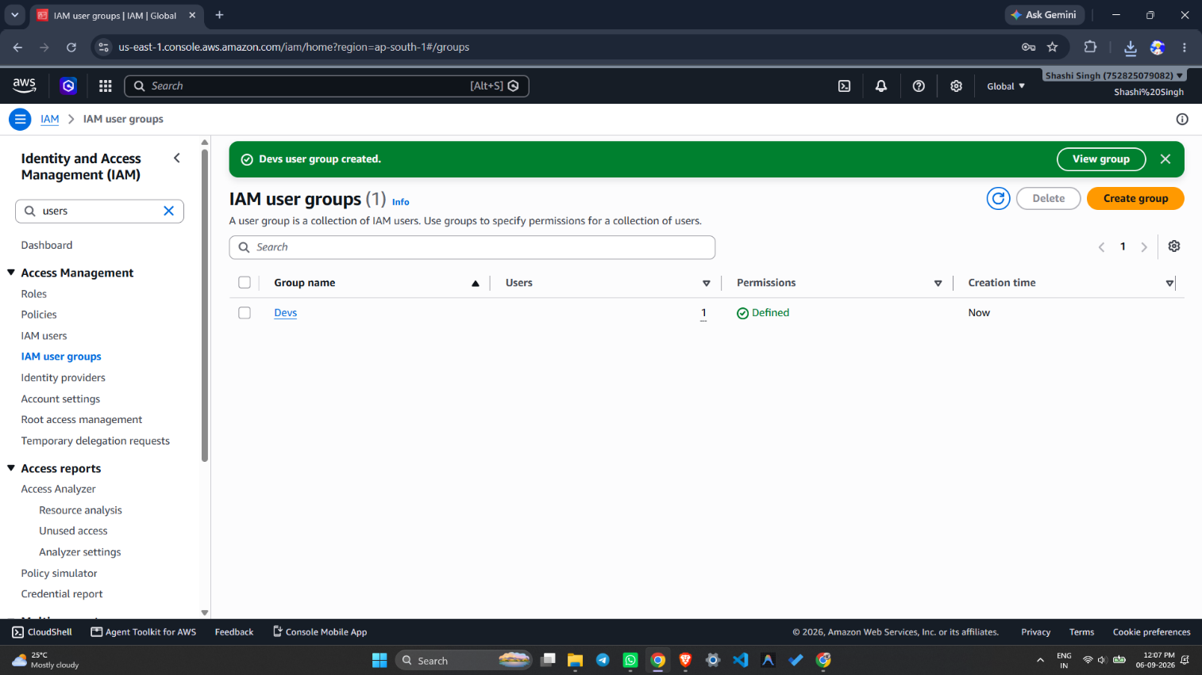

- Screenshot 4: IAM Policy Simulator — ListBucket: Allowed, PutObject: Denied

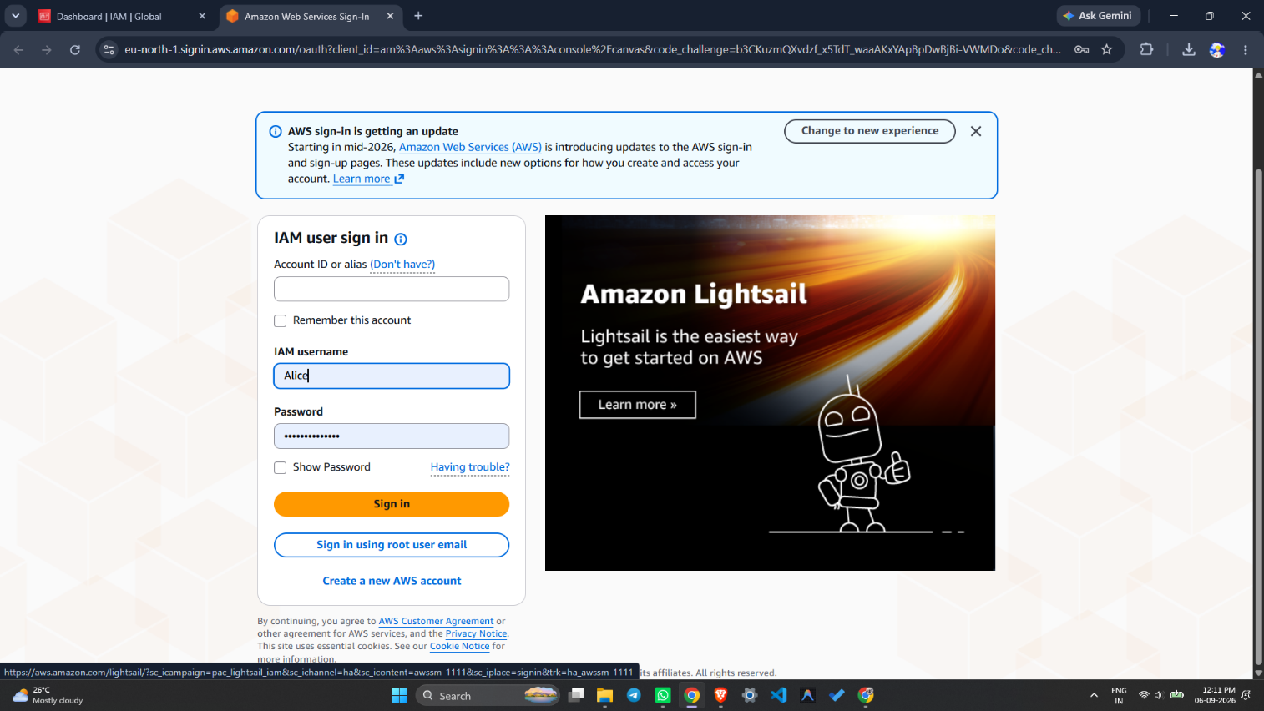

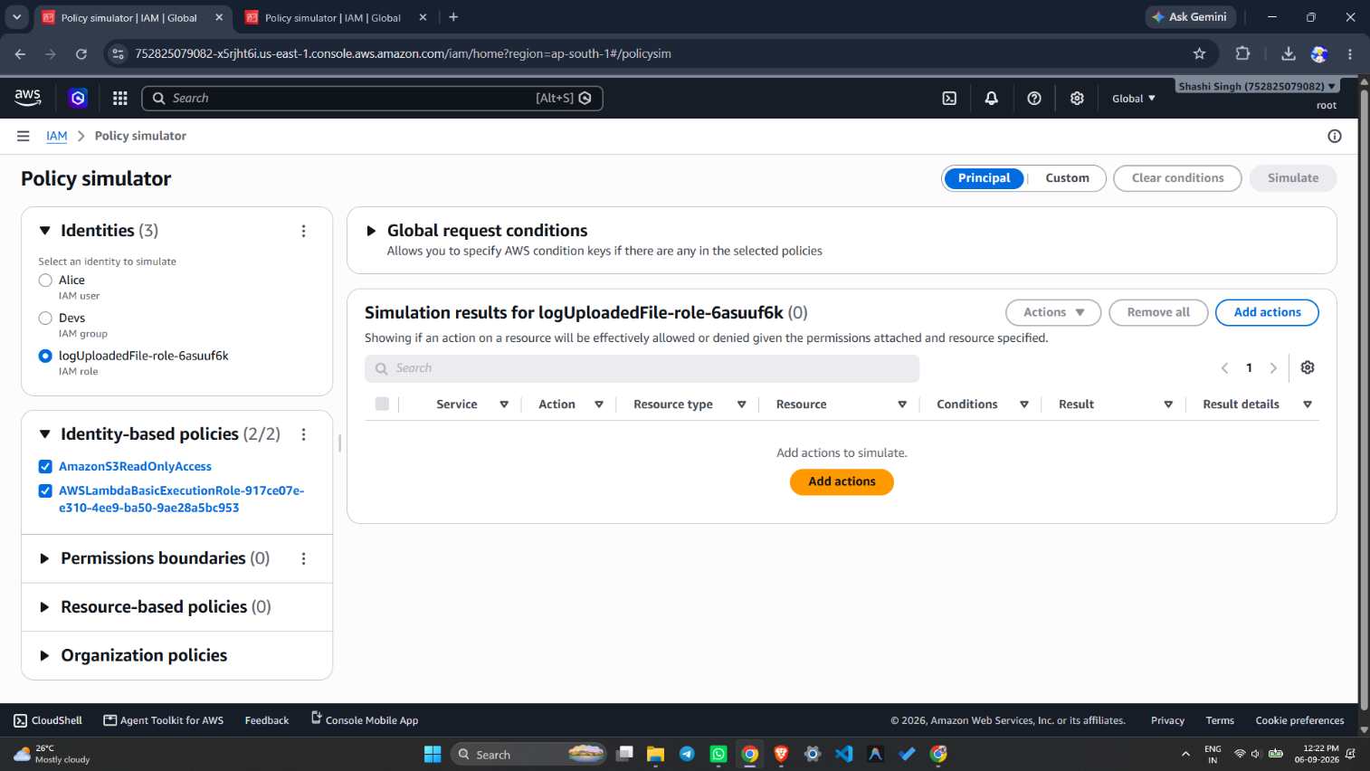
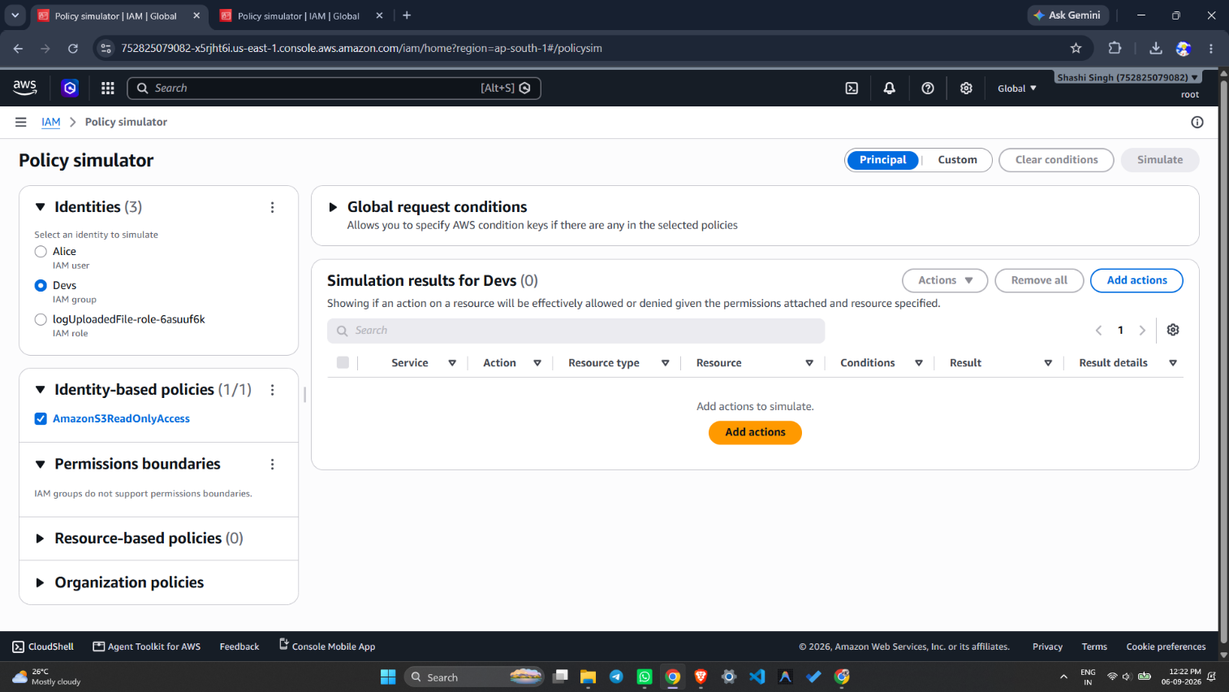

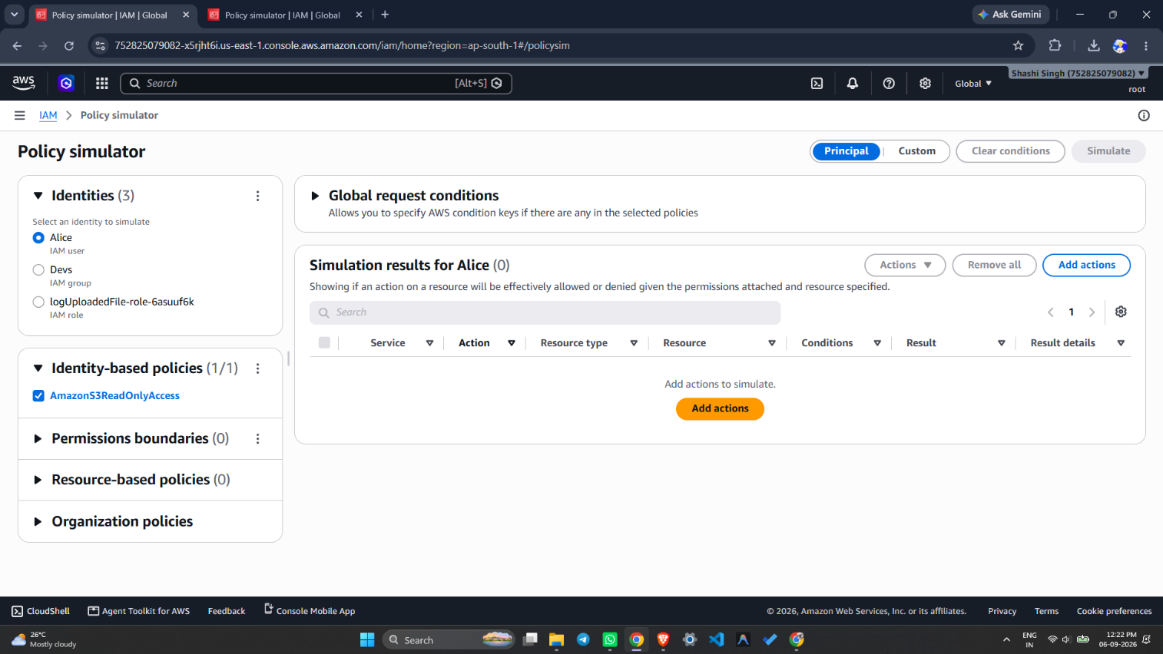

Result:
Successfully created IAM users, groups, roles, and policies in AWS. The IAM user "Alice" was created and assigned AmazonS3ReadOnlyAccess, and was added to the "Developers" group. A custom IAM policy S3ReadOnlyPolicy was created using JSON and attached to the user/group. An IAM role EC2S3AccessRole was created for the EC2 service. Permissions were verified using the IAM Policy Simulator, which confirmed that ListBucket and GetObject were Allowed while PutObject was Denied for the IAM user Alice.

References:
- https://docs.aws.amazon.com/IAM/latest/UserGuide/introduction.html
- https://docs.aws.amazon.com/IAM/latest/UserGuide/access_policies.html
- https://policysim.aws.amazon.com
- https://docs.aws.amazon.com/IAM/latest/UserGuide/id_roles.html

Exp No: 4 | Launching EC2 Instances Using PuTTY
06-09-2026 | Launching EC2 Instances Using PuTTY

Aim:
- To launch an Amazon EC2 instance using the AWS Management Console.
- To install and configure PuTTY on a Windows system for secure remote access.
- To connect to the EC2 instance using PuTTY and execute basic Linux commands.

Objectives:
- To understand the concept of virtual servers (instances) in AWS EC2.
- To learn the step-by-step process of launching a Free Tier eligible EC2 instance.
- To understand the role of key pairs and security groups in securing SSH access.
- To install and configure PuTTY and PuTTYgen for remote SSH connections.
- To establish an SSH connection to the EC2 instance using PuTTY.
- To verify the connection by executing basic Linux commands on the instance.

Tools Used:
- Amazon Web Services (AWS) Management Console
- Amazon EC2 (Elastic Compute Cloud)
- PuTTY (SSH Client)
- PuTTYgen (Key Generator)
- Pageant (SSH Authentication Agent)
- Windows Operating System

Theory:
Amazon EC2 (Elastic Compute Cloud) is a web service that provides resizable compute capacity in the cloud, allowing users to launch and manage virtual servers called instances on demand.

PuTTY is a free, open-source, and lightweight terminal emulator, serial console, and network file transfer application that allows users to connect securely to remote computers over a network, especially from Windows systems.

Terminal Emulator: Acts like a window where commands can be typed to communicate with another computer, such as a remote server (similar to interacting with a chatbot).
Serial Console: Allows a direct connection to another device, such as a router or server, through a cable, often used for troubleshooting when the network is not working (similar to plugging a monitor and keyboard directly into a computer to control it without an internet connection).
Network File Transfer Application: Allows files to be sent or received between computers over a network (similar to using Google Drive or email attachments, but performed from the command line to upload or download files between a local computer and a remote server).

Procedure:
Part A: Launching an EC2 Instance
Step 1: Launch an Instance
- Open the Amazon EC2 console at https://console.aws.amazon.com/ec2/
- In the navigation bar, note the current AWS Region, or select a Region closer to you.
- From the EC2 console dashboard, in the Launch instance pane, choose Launch instance.
- Under Name and tags, enter a descriptive name for the instance.
- Under Application and OS Images (AMI), choose Quick Start, select an operating system (Amazon Linux recommended), and choose an AMI marked Free Tier eligible.
- Under Instance type, choose t2.micro (or t3.micro where t2.micro is unavailable), which is eligible for the Free Tier.
- Under Key pair (login), choose an existing key pair or choose Create new key pair to create one. (Proceeding without a key pair prevents connecting to the instance.)
- Under Network settings, note the default VPC, default subnet, and a security group rule allowing connections from anywhere (0.0.0.0/0).
- Under Configure storage, note the default root volume configured (sufficient for test purposes).
- Review the configuration in the Summary panel, then choose Launch instance.
- If the launch succeeds, choose the instance ID from the Success notification to open the Instances page and monitor the launch status.
- Select the instance checkbox. Its state changes from pending to running; once it passes status checks (Status and alarms tab), it is ready to accept connections.

Part B: Installing and Setting Up PuTTY
Step 2: Download PuTTY
- Go to the official PuTTY download page: https://www.putty.org/
- Choose the right version: 64-bit installer (putty-64bit-0.81-installer.msi) for modern Windows 10/11 systems, or the 32-bit installer for older systems.

Step 3: Install PuTTY
- Run the downloaded .msi installer and follow the installation wizard.
- Select "Install for anyone who uses this computer" (recommended) and keep the default installation location (usually C:\Program Files\PuTTY\).
- Ensure the following components are selected: PuTTY (SSH client), PuTTYgen (key generator), and Pageant (SSH authentication agent, optional).
- Complete the installation.

Step 4: Get the Instance's Public DNS
- In the AWS EC2 console, select the running instance.
- In the Description tab, locate "Public DNS (IPv4)", which looks like ec2-xx-xxx-xxx-xxx.compute-1.amazonaws.com.
- Copy this address for use in the PuTTY connection.

Step 5: Configure the PuTTY Connection
- Open PuTTY and, in the "Host Name" field, enter ec2-user@your-public-dns (replacing your-public-dns with the copied address).
- In the left menu, expand Connection > SSH > Auth, click Browse, and select the .ppk private key file.
- Return to Session in the left menu, enter a name under Saved Sessions (e.g., "MyEC2Instance"), and click Save.

Step 6: Connect to the Instance
- Click Open to start the connection.
- If a security alert appears, click Yes to trust the host.
- A terminal prompt similar to [ec2-user@ip-xxx-xxx-xxx-xxx ~]$ confirms a successful connection to the EC2 instance.

Step 7: Verify the Connection
- Run the pwd command at the terminal prompt to display the current working directory and confirm the shell session is active.

Output:
- EC2 console — Name and AMI selection for the new instance
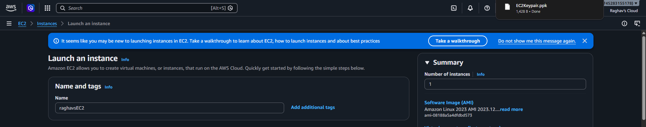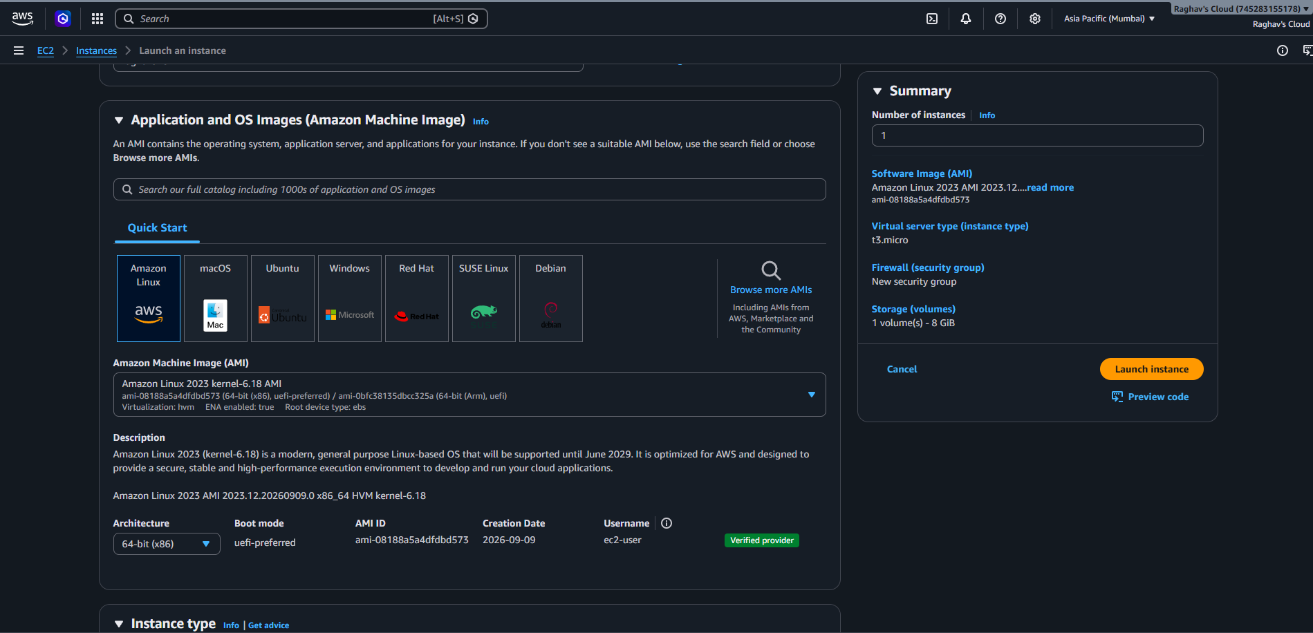
- Instance type (t3.micro) and key pair creation/selection
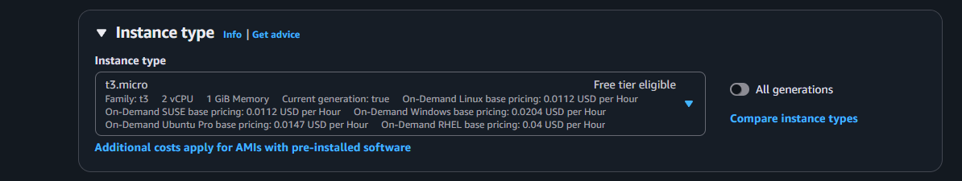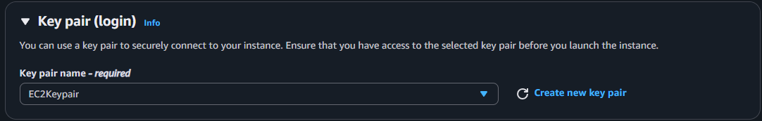
- Network settings and storage configuration summary
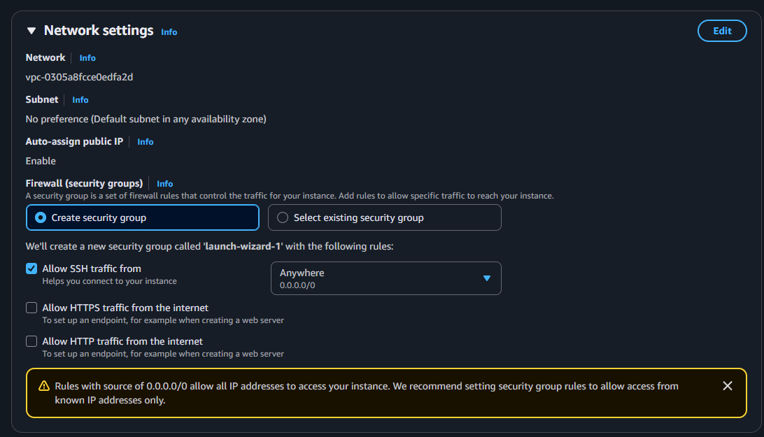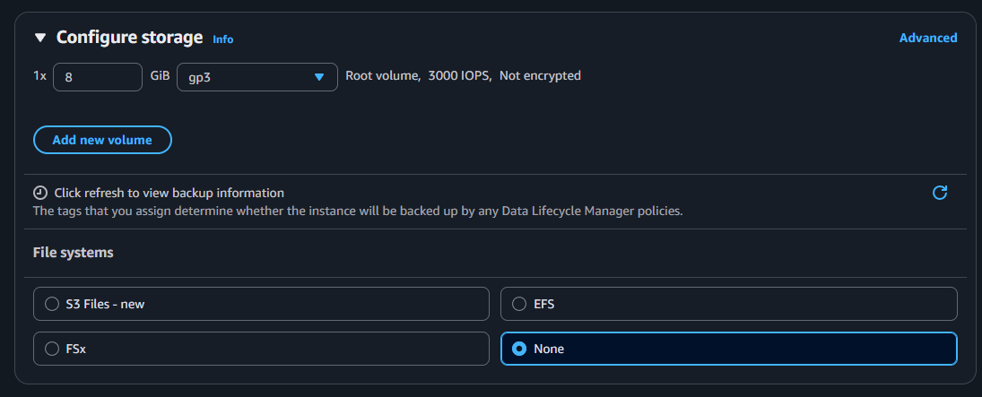
- Instance successfully launched — Instances page showing state: running
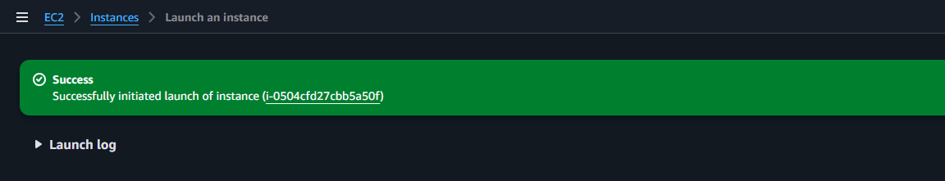
[Insert screenshot here]
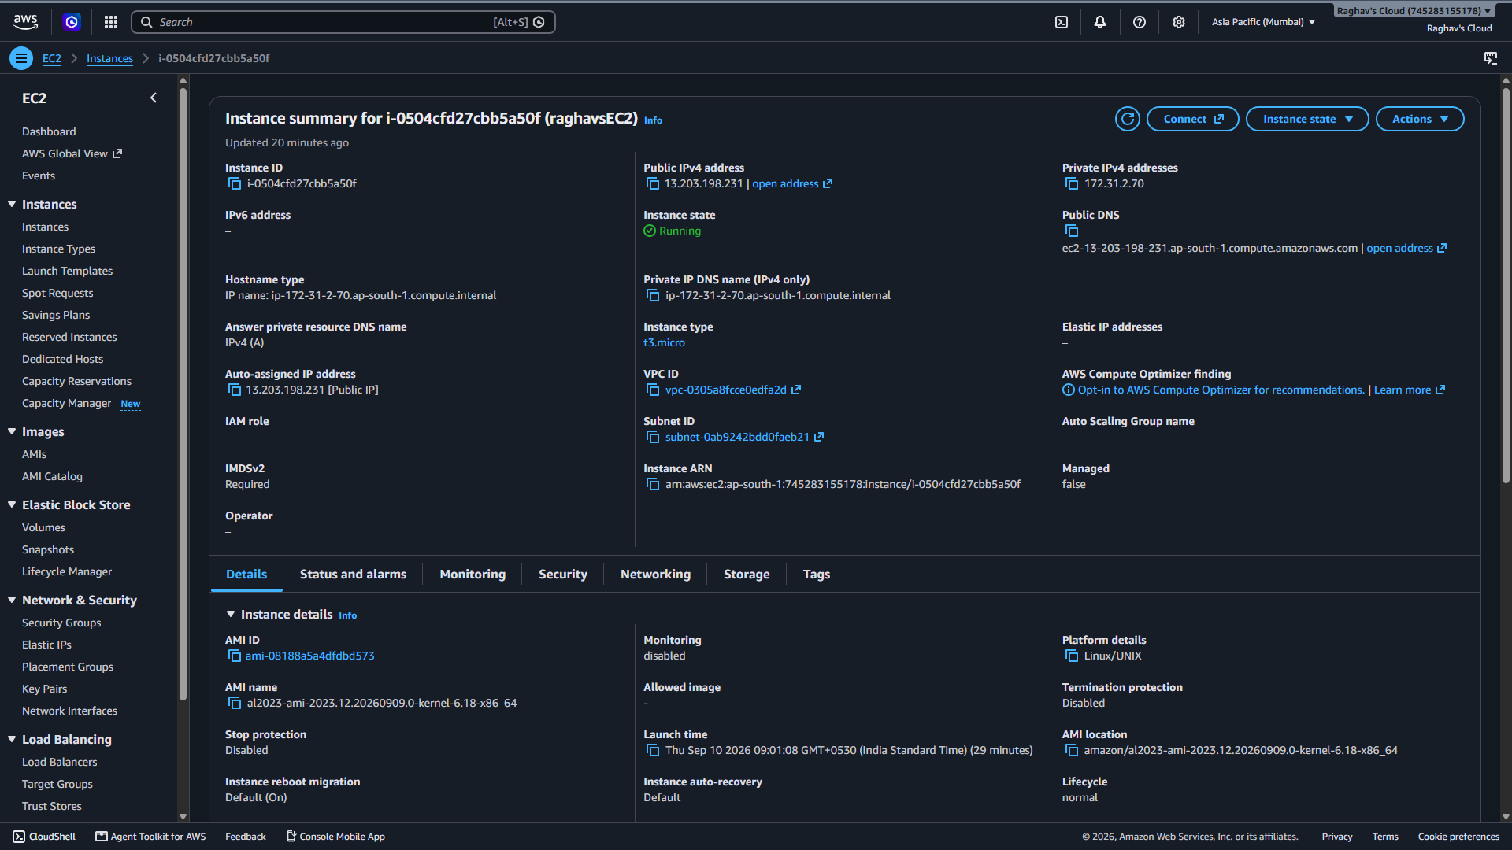

- Instance status checks passed (Status and alarms tab)
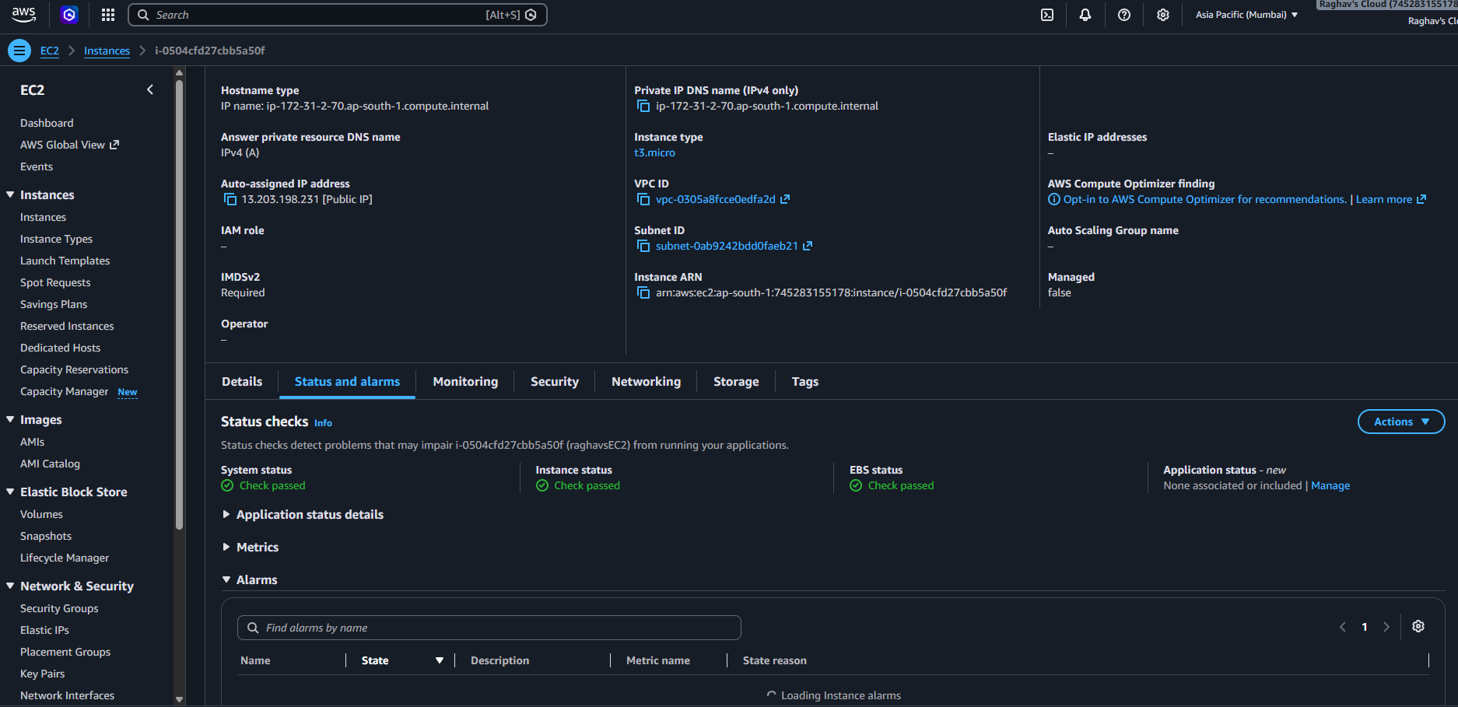
- EC2 instance Public DNS (IPv4) copied from the instance description
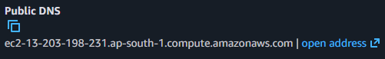

- PuTTY Session configured with Host Name and .ppk key under Connection > SSH > Auth
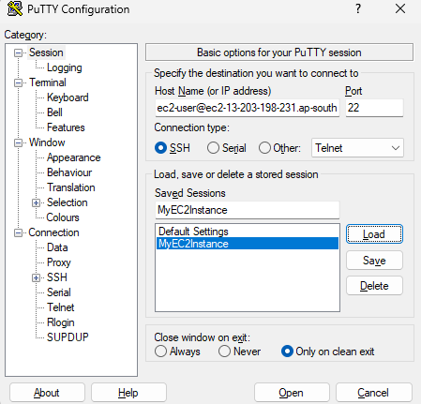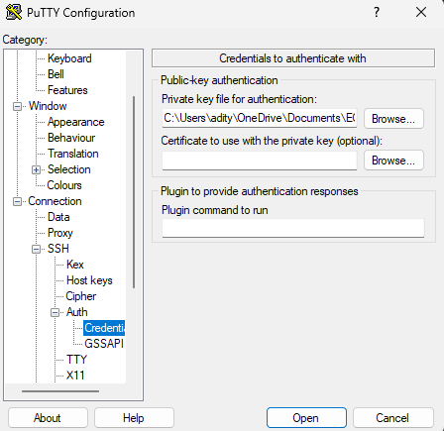

- Successful SSH connection — terminal prompt and output of the pwd command
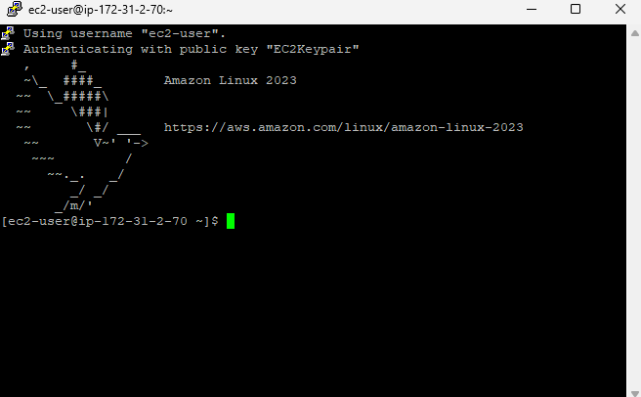

Result:
An Amazon EC2 instance was successfully launched from the AWS Management Console using a Free Tier eligible AMI and instance type, secured with a key pair and a default security group. PuTTY was downloaded, installed, and configured on a Windows system, and an SSH connection was established to the running instance using its Public DNS and private key. The connection was verified by executing the pwd command at the EC2 terminal prompt.

References:
- https://docs.aws.amazon.com/AWSEC2/latest/UserGuide/EC2_GetStarted.html
- https://docs.aws.amazon.com/AWSEC2/latest/UserGuide/ec2-key-pairs.html
- https://www.putty.org/
- https://docs.aws.amazon.com/AWSEC2/latest/UserGuide/putty.html

Exp No: 5 | Hands-on Session on Elastic Beanstalk
06-09-2026 | Hands-on Session on Elastic Beanstalk

Aim:
- To create and deploy a sample web application using AWS Elastic Beanstalk.
- To explore, update, and scale an Elastic Beanstalk environment, and clean up the associated resources.

Objectives:
- To understand the concept of Platform as a Service (PaaS) using AWS Elastic Beanstalk.
- To create an Elastic Beanstalk application and configure an environment with the required service and instance profile roles.
- To understand the AWS resources (EC2, S3, CloudWatch, CloudFormation) that Elastic Beanstalk provisions automatically.
- To connect to the underlying EC2 instance using Session Manager and view application logs.
- To deploy an updated version of the application and verify the update.
- To scale the environment's capacity using Auto Scaling and verify the change.
- To clean up all application versions, environments, and resources after the exercise.

Tools Used:
- AWS Elastic Beanstalk
- Amazon EC2 (Elastic Compute Cloud)
- AWS IAM (Identity and Access Management)
- Amazon S3 (Simple Storage Service)
- Amazon CloudWatch
- AWS CloudFormation
- AWS Systems Manager — Session Manager
- PHP (Sample Application Runtime)

Theory:
AWS Elastic Beanstalk is a Platform as a Service (PaaS) offering that makes it easy to deploy and manage web applications without needing to manage the underlying infrastructure directly. A developer only needs to upload their application code, while Elastic Beanstalk automatically handles provisioning, load balancing, auto scaling, and application health monitoring.

When an application is created, Elastic Beanstalk automatically provisions several supporting resources: an EC2 instance to run the web application, a security group to allow inbound traffic, an S3 bucket to store source code and logs, CloudWatch alarms to monitor instance load, a CloudFormation stack to manage the environment's resources, and a domain name in the form subdomain.region.elasticbeanstalk.com through which the application can be accessed.

Service Role: A role that allows Elastic Beanstalk to monitor EC2 instances and upgrade the environment's platform on the user's behalf.
EC2 Instance Profile Role: A role attached to the EC2 instance itself, permitting tasks such as writing logs and interacting with other AWS services.

Procedure:
Step 1: Create an Application
Create the Application
- Open the Elastic Beanstalk console and choose Create application.
- For Application name, enter getting-started-app.
Configure an Environment
- In Environment information, for Environment name, enter gs-app-web-env.
- For Platform, choose the PHP platform.
- For Application code and Presets, accept the defaults (Sample application and Single instance), then choose Next.
Configure Service Access
- Two IAM roles are required: a Service role, which allows Elastic Beanstalk to monitor EC2 instances and upgrade the environment's platform, and an EC2 instance profile role, which permits tasks such as writing logs and interacting with other services.
Create the Service Role
- For Service role, choose Create role.
- For Trusted entity type, choose AWS service, and for Use case, choose Elastic Beanstalk – Environment, then choose Next.
- Verify that the permissions policies include AWSElasticBeanstalkEnhancedHealth and AWSElasticBeanstalkManagedUpdatesCustomerRolePolicy, then choose Next.
- Choose Create role, then return to the Configure service access tab, refresh the list, and select the newly created service role.
Create the EC2 Instance Profile
- Choose Create role. For Trusted entity type, choose AWS service, and for Use case, choose Elastic Beanstalk – Compute, then choose Next.
- Verify that the permissions policies include AWSElasticBeanstalkWebTier, AWSElasticBeanstalkWorkerTier, and AWSElasticBeanstalkMulticontainerDocker, then choose Next.
- Choose Create role, then return to the Configure service access tab, refresh the list, and select the newly created EC2 instance profile.
Finish Configuring and Creating the Application
- Skip over EC2 key pair (other connection methods are available through the console).
- Choose Skip to Review, or select VPC default, subnets 1a and 1b, and accept all default configurations for the optional steps (networking, databases, scaling, advanced configuration, monitoring, and logging).
- On the Review page, verify the summary of choices and choose Submit.

Step 2: Deploy the Application
- Once created, Elastic Beanstalk sets up the environment automatically; the initial deployment can take up to five minutes, while later updates deploy faster since only changes are applied.
- Elastic Beanstalk provisions an EC2 instance, an instance security group (allowing inbound traffic on port 80), an S3 bucket, CloudWatch alarms, a CloudFormation stack, and a domain name for the application.
- Progress is tracked and displayed in the Events tab; once all resources are deployed, the environment's health changes to Ok.

Step 3: Explore the Elastic Beanstalk Environment
- Open the Elastic Beanstalk console, select the AWS Region, choose Environments, and select the environment from the list.
- Choose Go to environment (or the Domain URL link) to browse the deployed application. The connection is over HTTP, so a browser warning may appear.
- While resources are being created, the environment is in a Pending state, with status messages continuously added under Events.
- The Configuration link in the left navigation pane displays a summary of the environment's configuration option values, grouped by category.
Add a Policy to Enable Connections to EC2
- Navigate to the IAM console and find and select the aws-elasticbeanstalk-ec2-role role.
- Choose Add permission, then Attach policies, search for a default policy beginning with AmazonSSMManagedEC2Instance, and add it to the role.
Connect to the EC2 Instance with Session Manager
- Navigate to the Amazon EC2 console, choose Instances, and select the gs-app-web-env instance.
- Choose Connect, then Session Manager, then Connect.
- In the session, run bash, then cd /var/log/nginx, then tail -f access.log.
- In a browser, open the application domain URL and refresh; new log entries should appear in the terminal on every refresh.

Step 4: Update the Application
- A new application version can be deployed at any time, provided no other update operation is in progress on the environment. The tutorial starts with the Sample Application version.
Create a PHP Sample Application
- Folder structure:
php-hello-app/
├── index.php
└── .htaccess

- index.php:
<!DOCTYPE html>
<html>
<head><title>My First PHP Page</title></head>
<body>
<h1>Hello from PHP!</h1>
<?php echo "This line is printed using PHP."; ?>
</body>
</html>

- .htaccess:
RewriteEngine On
RewriteCond %{REQUEST_FILENAME} !-f
RewriteCond %{REQUEST_FILENAME} !-d
RewriteRule ^(.*)$ index.php [L]

- RewriteEngine On turns on the Apache rewrite feature; without it, the rewrite rules below are ignored.
- RewriteCond %{REQUEST_FILENAME} !-f continues only if the requested file does not already exist.
- RewriteCond %{REQUEST_FILENAME} !-d continues only if the requested folder does not already exist.
- RewriteRule ^(.*)$ index.php [L] redirects any unmatched path to index.php, with [L] marking it as the last rule to apply.

- Compress the folder (Send to → Compressed (zipped) folder) to produce php-hello-app.zip, containing index.php and .htaccess.
- Open the Elastic Beanstalk console, select the AWS Region, choose Environments, and select the environment from the list.
- On the environment overview page, choose Upload and deploy, then Choose file and upload the source bundle (php-hello-app.zip).
- The console automatically fills in a unique Version label (or a custom one can be entered), then choose Deploy.
- While the file is deployed, the deployment status is visible on the Environment overview page; the environment Health status turns gray during the update.
- Once the deployment completes, Elastic Beanstalk performs an application health check; when it responds successfully, health returns to green and the Running Version updates. The new version is also added to the Application versions table.
- Refresh the browser to confirm the update — an updated "v2" message should now be visible.

Step 5: Scale the Application
- Environment configuration, such as EC2 instance type or capacity, can be changed at any time. Elastic Beanstalk performs an environment update to apply changes — some are quick, while others (like capacity changes) may take several minutes and can cause temporary downtime.
Increase Capacity Settings
- Open the Elastic Beanstalk console, select the AWS Region, choose Environments, and select the environment.
- In the navigation pane, choose Configuration, then in the Instance traffic and scaling configuration category, choose Edit.
- Collapse the Instances section to reveal Capacity, and under Auto Scaling group, change Environment type to Load balanced.
- In the Instances row, change Min to 2 and Max to 4, then choose Apply at the bottom of the page.
- If warned that the update will replace current instances, choose Confirm. The update can take a few minutes; watch the Events list for Successfully deployed new configuration to environment.
Verify Increased Capacity
- Choose Health from the tab list or left navigation pane and review the Enhanced instance health section, or open the EC2 console, choose Instances, and confirm the number of running instances has increased.

Cleaning Up the Elastic Beanstalk Environment
- To avoid being charged for unused resources, delete all application versions and terminate the environment, which also deletes the AWS resources the environment created.
Delete Application Versions
- Open the Elastic Beanstalk console, select the AWS Region, choose Applications, then getting-started-app, then Application versions.
- Select all application versions to delete, choose Actions, then Delete, turn on Delete versions from Amazon S3, then choose Delete and Done.
Terminate the Environment
- Choose getting-started-app, then select GettingStartedApp-env in the environment list, choose Actions, then Terminate Environment.
- Confirm by typing the environment name, then choose Terminate.
Delete the Application
- Select getting-started-app, choose Actions, then Delete application.
- Confirm by typing the application name, then choose Delete.

Output:
- Elastic Beanstalk application created — getting-started-app with environment gs-app-web-env
[Insert screenshot here]
- Service role and EC2 instance profile role created and attached under Configure service access
[Insert screenshot here]
- Environment successfully created — health status Ok
[Insert screenshot here]
- Application accessed via the environment's domain URL — Sample Application page
[Insert screenshot here]
- IAM policy AmazonSSMManagedEC2Instance attached to the aws-elasticbeanstalk-ec2-role role
[Insert screenshot here]
- Session Manager connected to the EC2 instance, showing nginx access.log being tailed
[Insert screenshot here]
- Updated application deployed — browser showing the new "v2" / Hello from PHP! message
[Insert screenshot here]
- Environment capacity increased — Auto Scaling group configured with Min 2, Max 4
[Insert screenshot here]
- Enhanced instance health showing two running EC2 instances after scaling
[Insert screenshot here]
- Application versions, environment, and application successfully deleted (cleanup confirmation)
[Insert screenshot here]

Result:
An AWS Elastic Beanstalk application (getting-started-app) was successfully created and deployed with a PHP sample application, using a dedicated service role and EC2 instance profile role. The underlying EC2 instance was accessed using Session Manager to view live nginx logs. The application was updated to a custom PHP page and the update was verified in the browser. The environment's capacity was scaled from a single instance to a load-balanced Auto Scaling group with a minimum of two and a maximum of four instances, which was verified through the enhanced instance health view. Finally, all application versions, the environment, and the application were cleanly deleted to avoid incurring further charges.

References:
- https://docs.aws.amazon.com/elasticbeanstalk/latest/dg/Welcome.html
- https://docs.aws.amazon.com/elasticbeanstalk/latest/dg/GettingStarted.html
- https://docs.aws.amazon.com/elasticbeanstalk/latest/dg/using-features.iam.html
- https://docs.aws.amazon.com/systems-manager/latest/userguide/session-manager.html

